AYURSUTRA BOT

PESONALIZED INSIGHTS FOR HOLISTIC WELL-BEING
Bachelor of Technology
In

Computer Science and Engineering (Internet of Things)
By
Pagadala Divya 2211CS050081

Under the esteemed guidance of

Mrs. T. Suneetha (Assistant Professor)



Department of Computer Science & Engineering (CS & IOT)

Malla Reddy University

Maisammaguda, Dulapally, Hyderabad, Telangana

2024



Department of Computer Science & Engineering (Internet of Things)

CERTIFICATE

This is to certify that the project report of the application development entitled
“AYURSUTRA BOT: PERSONALIZED INSIGHTS FOR HOLISTIC
WELL-BEING”, submitted by Pagadala Divya (2211CS050081), of 3rd year IOT -Alpha Department of Computer Science and Engineering, Malla Reddy University ,Hyderabad, is a record bonafide work done by him/her. The results embodied in this report have not been submitted to any other university or institute for the award of any degree or diploma.

Internal Guide Head of the department
Mrs. T. Suneetha Dr.G.Anand Kumar
Assistant Professor, CS & IOT CSE(IoT)

External Examiner

DECLARATION

We hereby declare that the project report “ AyurSutra Bot: Personalized Insights for Holistic Well-being”, has been carried out by us and this work has been submitted to the Department of Computer Science Engineering (Internet of Things) , Malla Reddy University, Hyderabad in partial fulfilment of the requirements for the award of degree of Bachelor of Technology .We further declare that this project work has not been submitted in full or part for the award of any other degree in any other educational institutions.

Pagadala Divya 2211CS050081

ACKNOWLEDGEMENT

We extend our sincere gratitude to all those who have contributed to the completion of this project report. Firstly, we would like to extend our gratitude to Dr. V. S. K Reddy, Vice-Chancellor, for his visionary leadership and unwavering commitment to academic excellence.
We would also like to express our deepest appreciation to our project guide Mrs.
T. Suneetha Assistant Professor whose invaluable guidance, insightful feedback, and unwavering support have been instrumental throughout the course of this project for successful outcomes.
We extend our gratitude to our PRC – convenor, Dr. G. Latha, for giving valuable inputs and timely guidelines to improve the quality of our project through a critical review process.
We thank our project coordinator, Mr.Ramesh Khanna, for his timely support. We are also grateful to Dr. G. Anand Kumar, Head of the Department internet of things, for providing us with the necessary resources and facilities to carry out this project.
We would like to thank Dr. Kasa Ravindra, Dean, School of Engineering, for his encouragement and support throughout my academic pursuit.
My heartfelt thanks also go to Dr. Harikrishna Kamatham, Associate Dean School of Engineering for his guidance and encouragement.
We are deeply indebted to all of them for their support, encouragement, and guidance, without which this project would not have been possible.

ABSTRACT

The AyurSutra Chatbot: Personalized Insights for Holistic Well-being is an innovative project designed to provide personalized Ayurvedic health insights by integrating the wisdom of Ayurveda with modern machine learning techniques. The chatbot is designed to assess a user's Prakruti (body constitution), diagnose prevalent health issues, and recommend Ayurvedic remedies, lifestyle changes, and dietary modifications. By utilizing machine learning algorithms, the chatbot offers tailored health advice and insights that help individuals improve their well-being in a holistic manner.

Ayurveda, an ancient system of medicine from India, categorizes individuals into three main doshas—Vata, Pitta, and Kapha—which are believed to govern various physical and mental attributes. The chatbot uses a set of questions to determine the dominant dosha in a user, which helps in understanding their unique health profile. By assessing the user's responses, it computes the Prakruti and identifies the dosha imbalance, offering specific lifestyle suggestions and Ayurvedic recommendations for the individual’s optimal health.

In addition to the Prakruti assessment, the AyurSutra Chatbot offers users a platform to inquire about common health concerns. By processing the user’s query and matching it with a comprehensive database of health issues, the chatbot retrieves personalized Ayurvedic remedies. These remedies include herbal treatments, dietary changes, and recommended exercises that align with the Ayurvedic principles of balance and harmony.

The underlying methodology of the project relies on machine learning models that are trained on datasets related to Ayurvedic treatments, remedies, and Prakruti types. These models analyze user inputs and match them to predefined patterns of health

issues or dosha imbalances. For instance, if a user mentions symptoms such as fatigue or indigestion, the system cross-references this information with the database to provide relevant solutions. This approach helps ensure that the advice provided is not only personalized but also scientifically grounded.

Furthermore, the project integrates data visualization techniques to display the results. A graphical representation of dosha scores is generated to help users better understand their dominant Prakruti type. This visualization makes it easier for users to interpret the results of their Prakruti assessment and take actionable steps toward achieving a more balanced and healthy lifestyle.

In conclusion, the AyurSutra Chatbot represents a significant step forward in the intersection of technology and traditional medicine. By harnessing machine learning to provide personalized health advice, it offers users the opportunity to take charge of their health in a more holistic, informed, and natural way. Through its innovative approach, the project has the potential to empower individuals to make healthier lifestyle choices based on their unique physiological makeup, thereby contributing to the overall well- being of users.

TABLE OF CONTENTS

- Introduction
  - Problem Definition & Description
  - Objective of the Project
  - Scope of the Project
- System Analysis
  - Existing System
    - Background & Literature Survey
    - Limitations of Existing System
  - Proposed System
    - Advantages of Proposed System
  - Software & Hardware Requirements
    - Software Requirements
    - Hardware Requirements
  - Feasibility Study
    - Technical Feasibility
    - Robustness & Reliability
    - Economic Feasibility
- Architectural Design
  - Modules Design
    - Data Pre-processing
    - Feature Extraction & Selection
    - Number of Modules as per analysis
  - Project Architecture
    - Complete architecture
    - Data Flow & Process Flow Diagrams
    - Class Diagram
    - Use case Diagram
    - Sequence Diagram
    - Activity Diagram
- Implementation
  - Coding Blocks
  - Sample Code

  - Execution Flow
  - Testing
- Conclusions & Future Scope
  - Refrences
  - Future scope
  - Result
  - Conclusions

- INTRODUCTION

Problem Definition & Description

The growing reliance on technology in the healthcare sector has highlighted the need for personalized health solutions that cater to individual needs. While modern medicine offers significant advancements, many people still seek alternative, holistic approaches to health, with Ayurveda being one of the oldest and most respected systems of medicine. Ayurveda offers a comprehensive framework for understanding human health based on the balance of three primary doshas—Vata, Pitta, and Kapha. However, due to its complexity and the lack of accessible resources, many individuals are unable to make full use of Ayurvedic principles in managing their health. The problem lies in the difficulty people face in applying Ayurveda’s vast knowledge to their daily lives, which often leads to misunderstandings and inefficiencies in self-care.

The AyurSutra Bot: Personalized Insights for Holistic Well-being is an innovative project that merges the ancient wisdom of Ayurveda with modern machine learning and artificial intelligence technologies. Ayurveda, an ancient system of medicine that originated in India, focuses on balancing the body's energies (doshas: Vata, Pitta, and Kapha) to maintain physical, mental, and emotional health. Over thousands of years, Ayurveda has proven to be a highly effective means of promoting holistic well-being, using natural remedies, personalized diets, and lifestyle adjustments. However, with the increasing complexity of modern life and the limited accessibility of Ayurvedic practitioners, there is a need to make this knowledge more accessible to a wider audience.

The AyurSutra Bot aims to address this gap by leveraging the power of AI to offer personalized health assessments based on the Ayurvedic concept of Prakruti, or body constitution. The bot uses a series of diagnostic questions to determine the user’s dominant dosha (Vata, Pitta, or Kapha), which is key to understanding their unique physical and mental traits. By identifying the dosha imbalances, the bot can suggest customized recommendations for diet, lifestyle, and wellness practices that are tailored to the user's individual needs. These personalized suggestions are rooted in Ayurvedic principles, ensuring that users receive accurate and relevant advice for maintaining their overall health.

Additionally, with the increasing prevalence of lifestyle-related diseases, such as stress, obesity, and digestive disorders, there is a growing demand for personalized healthcare solutions that address the root cause of these issues rather than just symptoms. Many individuals seek natural remedies and wellness solutions, but there is a lack of accessible, reliable, and personalized platforms that can provide Ayurveda-based insights in an easily understandable format. Without a structured, personalized framework, users often struggle to make decisions about diet, lifestyle, and remedies that align with their unique constitution or health needs. The absence of a platform that combines technology with Ayurveda for customized health advice leaves a gap in addressing this growing demand for personalized, natural healthcare solutions.

By utilizing machine learning, the bot learns and improves from user interactions, providing increasingly accurate and helpful responses over time. This makes it not just a static system, but a dynamic and evolving tool that grows in its ability to guide users toward healthier choices. The AyurSutra Bot provides a bridge between traditional healing systems and the technological advancements of today, making Ayurveda accessible to a broader, tech-savvy audience who are seeking natural and personalized health solutions.

The AyurSutra Chatbot addresses the need for personalized, accessible Ayurvedic guidance and remedies, making ancient Ayurvedic wisdom relevant to the modern user. The goal of this project is to provide individuals with actionable insights into their health by accurately diagnosing their Prakruti type and suggesting remedies that are tailored to their unique health profiles. By merging the science of Ayurveda with the power of machine learning, this project aims to bridge the gap between traditional medicine and contemporary technological solutions, ultimately contributing to the overall well-being of users.

Objective of the Project

The objective of this project is to develop a machine learning-based system that provides personalized Ayurvedic health insights by assessing the user’s Prakruti (body constitution). By evaluating the responses to a set of predefined questions, the system categorizes users into one of the three dosha types: Vata, Pitta, or Kapha, enabling a deeper understanding of their unique physical and mental characteristics. This classification forms the foundation for providing tailored Ayurvedic recommendations that can help individuals maintain balance and well-being.

Personalized Health Assessment:
To develop a machine learning-based system that can accurately assess the user's Prakruti (body constitution) by evaluating their responses to a set of predefined questions. This system will categorize users into one of the three dosha types: Vata, Pitta, or Kapha, based on their individual characteristics.

Ayurvedic Health Recommendations:
To provide personalized Ayurvedic recommendations, including lifestyle changes, dietary suggestions, home remedies, and yogic practices, based on the user’s dominant dosha and any health concerns or symptoms they may express.

Chatbot Functionality:
To create an interactive chatbot interface that allows users to communicate with the system in a conversational manner. Users can ask health-related questions and receive tailored Ayurvedic advice, making it accessible even for those unfamiliar with Ayurveda.

Integration of Machine Learning and Ayurveda:
To leverage machine learning algorithms to analyze user data and provide more accurate, customized advice based on historical health data, thus combining the principles of traditional Ayurvedic medicine with modern technological advancements.

User-Friendly Interface:
To design a user-friendly platform that enables non-technical users to easily interact with the chatbot and access personalized health insights. The platform will also ensure that the information is presented in a clear and understandable manner, making it accessible to a wider audience.

Enhance User Engagement:
Build a chatbot that not only gives personalized health suggestions but also engages users with quizzes, daily tips, and progress tracking to keep them motivated towards a healthier lifestyle.

Promote Mental and Emotional Well-being:
Include Ayurvedic practices that focus on emotional balance and mental health, recommending

specific techniques such as meditation, yoga, and breathing exercises suited to the user’s dosha type.

Empower Users with Preventive Health Practices:
Provide users with the tools and knowledge to prevent common ailments by aligning their daily routines with Ayurvedic principles, such as proper diet, sleep, and exercise tailored to their Prakruti.

Scope of the Project

The scope of the AyurSutra Bot project is broad, as it aims to merge traditional Ayurvedic practices with modern machine learning techniques to provide personalized health insights. The project focuses on evaluating a user's Prakruti (body constitution) by analyzing responses to a set of predefined questions. This evaluation classifies users into one of the three dosha types—Vata, Pitta, or Kapha. By understanding an individual’s dosha, the system is able to offer tailored lifestyle, dietary, and wellness recommendations, which are central to Ayurveda. The scope also extends to integrating a chatbot functionality, allowing users to interact and receive personalized health advice on-demand, making the system more user-friendly and accessible.

The scope of the AyurSutra Bot: Personalized Insights for Holistic Well-being project is multifaceted, aiming to combine modern technology with traditional Ayurvedic knowledge to enhance users’ health and well-being. The first major aspect of the scope is to offer personalized Ayurvedic health recommendations. The bot will assess a user's individual Prakruti (body constitution) and suggest tailored advice on diet, lifestyle, home remedies, and yoga practices. By focusing on the user's unique constitution, the system aims to guide them towards a balanced life, rooted in the ancient science of Ayurveda.

Another significant scope of the project is Prakruti detection and health insights. By asking users a set of specific questions, the bot can determine their dominant dosha (Vata, Pitta, or Kapha) and provide personalized health recommendations based on their body type. These suggestions will cover a wide range of health aspects, from dietary habits to emotional well-being, ensuring that users receive practical, actionable insights that align with their unique physiological makeup. This personalized approach offers a deeper level of self-awareness and health management.

Another significant aspect of the project is the application of machine learning to improve the personalization of recommendations. As the system interacts with more users and receives feedback, it can refine its suggestions based on patterns and insights from the collected data. This dynamic learning mechanism will enhance the quality and accuracy of the recommendations over time, ensuring that users receive more precise health advice as the system evolves. The project also aims to bridge the gap between ancient Ayurvedic knowledge and modern technology, making Ayurvedic health practices more accessible to a global audience.

The scope of this project also includes the integration of various health-related features such as lifestyle modifications, dietary suggestions, and yogic practices based on the identified dosha. It expands beyond simple Prakruti assessment by offering actionable steps for improving health and well-being. These personalized health recommendations will be designed to address both physical and mental health concerns, ensuring that users can achieve balance in all aspects of their lives. The system will provide not only guidance on food choices and daily routines but also suggestions for mental health improvements and stress management techniques rooted in Ayurveda.

In conclusion, the scope of the AyurSutra Bot project is comprehensive, aiming to empower individuals to take charge of their health through personalized Ayurvedic advice. It strives to make Ayurveda more relevant in the modern context by combining it with cutting-edge technology. The system’s potential extends to helping users achieve holistic well-being, fostering a preventative approach to health, and offering a platform where traditional wisdom meets contemporary needs.

SYSTEM ANALYSIS

Existing System
    - Background & Literature Survey
Ayurveda, one of the oldest systems of medicine in the world, originated in India over 5,000 years ago. It is based on the concept of balance within the body, mind, and spirit, and focuses on maintaining harmony between these elements to promote overall health and well-being. According to Ayurvedic principles, every individual has a unique combination of three fundamental energies or doshas—Vata, Pitta, and Kapha. These doshas determine a person's physical characteristics, personality traits, and susceptibility to diseases. Ayurveda provides comprehensive guidance on lifestyle, diet, and treatments based on an individual's Prakruti, or constitution, which helps maintain equilibrium and prevent diseases.

Ayurvedic Practices and Personalized Health:
Ayurveda emphasizes personalized healthcare, focusing on an individual’s unique Prakruti. According to Sharma (1996), Ayurveda promotes holistic well-being by aligning lifestyle, diet, and treatments with one’s dosha type. Recent studies highlight the importance of personalized medicine in improving overall health outcomes (Kumar & Singh, 2018).

Health Informatics and Data Analytics:
Data analytics helps in predicting health trends and personalizing treatments. Kumar et al. (2019) highlighted the role of data analytics in healthcare, which can be used to predict health conditions and suggest Ayurvedic remedies based on an individual’s health history and Prakruti.

Ayurveda and Data-Driven Health Solutions:
Data analytics can enhance Ayurvedic treatments by analyzing individual responses to health queries. Sharma (2006) discussed how Ayurveda’s individualized approach could benefit from modern data-driven solutions, which can help provide more accurate and personalized health advice based on Prakruti and lifestyle.

Machine Learning in Healthcare:
Machine learning (ML) has revolutionized healthcare by predicting diseases and providing personalized treatment plans. Wang et al. (2019) discussed ML's potential in healthcare, including its ability to analyze large datasets and enhance disease prediction, which can be adapted to Ayurvedic assessments.

Chatbots and Natural Language Processing (NLP) in Health care:
NLP and chatbots are increasingly used in healthcare to provide personalized advice. Gonzalez and Pujol (2020) reviewed NLP’s role in improving healthcare delivery by enabling real-time communication between users and automated systems, such as the AyurSutra Bot, which offers personalized Ayurvedic recommendations.

Limitations of Existing System

Limited Data Integration:
Existing systems often lack comprehensive integration of data from diverse sources, such as health records, genetic data, and lifestyle information. This limits the ability to generate highly personalized Ayurvedic recommendations based on a holistic view of the user's health.

Inaccurate Prakruti Assessment:
Many current Ayurvedic systems rely on simplistic questionnaires or rule-based algorithms for Prakruti assessment. These methods may not be accurate or comprehensive, leading to generalized recommendations rather than tailored advice based on an individual's specific health profile.

Limited Interaction and Engagement:
Most current Ayurvedic chatbot systems are limited in their conversational abilities. They often rely on basic responses and do not offer dynamic interactions. This reduces user engagement and may fail to address nuanced health queries that require more personalized or contextual responses.

Lack of Personalization in Remedies:
While existing systems may suggest general remedies, they often do not account for the varying degrees of effectiveness based on individual characteristics like age, health history, or Prakruti. This can result in suboptimal treatment plans for users.

Ethical and Privacy Concerns:
Many current health systems, including those incorporating AI, face challenges related to user data privacy, security, and ethical concerns. Without proper safeguards, user data can be vulnerable to breaches, compromising the confidentiality of sensitive health information.

Inadequate Use of AI and ML in Ayurveda:
Traditional Ayurvedic systems have not fully utilized the capabilities of AI and machine learning. The integration of these technologies for predictive analytics, personalized treatment plans, and more effective Prakruti analysis is still in its early stages, limiting their potential to revolutionize the field.

Proposed System
    - Advantages of Proposed System

Personalized Health Recommendations:
The AyurSutra Chatbot offers tailored Ayurvedic remedies and lifestyle changes based on an individual’s unique Prakruti and health condition, ensuring the advice is suitable for each user's needs.

Holistic Health Approach:
It provides a comprehensive, holistic view of health by addressing physical, mental, and emotional well-being through Prakruti analysis, which helps users maintain balance in all aspects of life.

Real-Time Feedback:
The system is capable of providing real-time health assessments and dynamic advice, adapting to changes in the user's health conditions or lifestyle choices over time.

User-Friendly Interface:
The chatbot offers an interactive, conversational interface that makes it easy for users to seek health advice without the need for complex inputs, ensuring a smooth and engaging user experience.

Accurate and Data-Driven Prakruti Assessment:
The bot uses machine learning algorithms and data analysis to assess an individual’s dosha

dominance, making the Prakruti assessment more accurate and scientifically backed.

Scalability and Accessibility:
Available online through a web interface, it makes Ayurvedic advice accessible to a larger audience, breaking geographical and logistical barriers to traditional healthcare consultations.

Privacy and Security:
User data, including health-related information, is stored securely with privacy-focused measures, ensuring that sensitive health details remain confidential.

Combining Tradition with Technology:
By merging Ayurvedic principles with modern AI technologies, the chatbot bridges the gap between traditional medicine and contemporary health practices, offering a blend of wisdom and innovation.

Cost-Effective Healthcare:
The chatbot reduces the need for costly in-person consultations, providing affordable health insights and Ayurvedic remedies for individuals seeking natural and preventive healthcare solutions.

Continuous Learning and Improvement:
The AI model continuously improves its recommendations through machine learning, offering better and more accurate advice as it learns from user interactions and feedback.

Software & Hardware Requirements
    - Software Requirements

Programming Languages:
      - Python: Primary programming language for backend development and machine learning model implementation.
o Python libraries used: pandas, numpy, scikit-learn, nltk, tensorflow, keras, streamlit, matplotlib, seaborn.

Libraries and Frameworks:
      - Streamlit: For building and deploying the interactive web interface of the chatbot.
      - scikit-learn: For implementing machine learning algorithms used for Prakruti assessment and

      - health recommendations.
      - TensorFlow / Keras: For training and deploying deep learning models (if used for NLP tasks).
      - NLTK (Natural Language Toolkit): For text processing and understanding user input queries in the health advice chat section.
      - pandas: For data handling, manipulation, and analysis, especially for loading and working with datasets (e.g., prakruti_data.csv, health_remedies_data.csv).
      - matplotlib & seaborn: For data visualization, such as plotting graphs to display Prakruti scores or other metrics.
      - Flask (optional): For API deployment if integrating with an external web application or for enhanced backend handling.

Operating System:
      - Windows, Linux, or macOS: The project can be developed and executed on any of these platforms, as long as the required Python environment and libraries are set up.

Development Environment:
      - VS Code / Jupyter Notebook / PyCharm: IDEs for coding, debugging, and running Python scripts. Jupyter Notebook is especially useful for data analysis, model building, and experimentation.

Web Server:
      - Streamlit Cloud / Heroku / AWS: For cloud-based deployment of the chatbot to make it accessible on the web. Streamlit can be deployed directly on Streamlit Cloud, or if additional back-end integration is required, services like Heroku or AWS can be used.

Hardware Requirements

Processor (CPU):
A multi-core processor such as Intel i5, i7, or equivalent AMD Ryzen processors is suitable for handling the computations involved in machine learning and data processing tasks.

Memory (RAM):
At least 8 GB of RAM is needed to handle large datasets and run machine learning algorithms smoothly, especially when dealing with multiple tasks simultaneously.

Storage:
Sufficient storage space (100 GB or more) is required to store project files, datasets, and model weights. Additional storage is needed if handling large datasets or working with multiple models.

Graphics Processing Unit (GPU):
A dedicated GPU is not mandatory but is highly recommended for faster model training, especially if deep learning models are used. A GPU such as NVIDIA GTX 1050 or equivalent is helpful for accelerating neural network training tasks.

Feasibility Study

    - Technical Feasibility

The AyurSutra Chatbot project, aimed at providing personalized Ayurvedic insights and health recommendations, is technically feasible due to the availability of suitable technologies, frameworks, and tools. The project leverages machine learning, natural language processing (NLP), and data analytics, all of which are supported by a wide range of open-source libraries and platforms. Below are the key aspects that demonstrate the technical feasibility:

Machine Learning Algorithms:
The project will utilize machine learning algorithms to analyze the user’s input, assess their Prakruti type (Vata, Pitta, or Kapha), and provide personalized recommendations. Libraries such as Scikit- learn, TensorFlow, and Keras offer robust tools for training and deploying models. These libraries support various algorithms like decision trees, random forests, and neural networks, making it possible to implement the required prediction models.

Natural Language Processing (NLP):
NLP techniques will be employed to interpret user queries regarding health issues. Libraries like
NLTK, spaCy, and transformers (for large language models like GPT) provide strong support for tokenizing, stemming, and understanding the context of text. NLP is essential for enabling the

chatbot to understand a wide range of health-related inquiries and provide Ayurvedic responses.

Data Availability and Integration:
The project will use health-related datasets containing information on Ayurvedic remedies for common health issues. With the proper integration of data sources (e.g., CSV files or a database), the chatbot can access and deliver relevant recommendations. Tools like Pandas and SQL will help manage and preprocess data efficiently.

Streamlit for Web Interface:
Streamlit is an ideal framework for quickly building interactive web applications with minimal coding. It allows the development of a user-friendly front-end for the AyurSutra Chatbot, enabling users to interact with the system via a simple interface. Streamlit's integration with Python libraries like Matplotlib and Plotly will allow for visualization of the Prakruti scores and other insights in real-time.

Cloud Deployment:
For scalability and global access, the chatbot can be hosted on cloud platforms like AWS, Google Cloud, or Heroku. These platforms provide the necessary computing power, storage, and security features to deploy machine learning models and chatbots. Cloud services like AWS Lambda can handle requests and run models in a serverless environment, while Google Cloud AI can be used for advanced AI features if needed.

Robustness & Reliability

The AyurSutra chatbot project has been designed with a focus on robustness and reliability, ensuring that it can effectively handle diverse user inputs and provide consistent outputs. The system leverages natural language processing (NLP) techniques to understand various phrasings of health-related queries. This adaptability is crucial in making sure that the chatbot responds appropriately, even when users phrase their questions differently. By using machine learning models that evolve with user input, the chatbot is able to improve over time, ensuring that it can handle a wide range of health inquiries with accuracy.

Error handling is another critical aspect of ensuring robustness. The chatbot has built-in mechanisms

to gracefully manage unexpected inputs or system failures. For example, if the chatbot encounters an input it cannot process, it will prompt the user to clarify or rephrase the question, reducing the chances of the system crashing or failing to respond. This ensures a smooth user experience, even in the case of errors or ambiguous inputs, and minimizes user frustration.

The reliability of the system is also demonstrated through its scalability. As more users interact with the chatbot, it needs to handle an increasing number of queries without compromising on performance. The system is designed to be scalable, using cloud infrastructure such as AWS or Google Cloud, which allows it to handle multiple concurrent users efficiently. This scalability ensures that the chatbot can maintain reliable performance, even with a growing user base, and that response times will remain consistent.

Data integrity is a key consideration for the AyurSutra chatbot. The system uses secure storage methods and encryption to protect the data exchanged between the user and the chatbot. Whether it's storing user inputs or health recommendations, the chatbot ensures that the data is safe from corruption or unauthorized access. This focus on data integrity helps maintain trust between the system and its users, as it ensures that sensitive information is handled responsibly.

To maintain consistent performance, the chatbot is built using reliable machine learning frameworks and algorithms. These models are periodically retrained to reflect the most up-to-date health information and user preferences. This regular maintenance ensures that the chatbot continues to provide accurate health advice and recommendations, making it a reliable tool for users seeking Ayurvedic insights.

Finally, the chatbot's reliability is also measured by user satisfaction. Continuous feedback from users allows for the ongoing improvement of the system. This feedback loop ensures that the chatbot evolves to meet the needs of users, providing more accurate, relevant, and personalized responses over time. By incorporating user input into its development, the system becomes more reliable and user-centric, ensuring long-term success.

Economic Feasibility

Economic feasibility assesses whether the AyurSutra Chatbot project can be developed and

maintained within the available budget while delivering value to both the users and stakeholders. This analysis evaluates the project's costs, potential returns, and long-term financial sustainability.

Development Costs:
Minimal costs as the project uses open-source tools (Python, Streamlit). The primary expenses will be for skilled personnel (developers, AI specialists) and cloud infrastructure setup.

Operational Costs:
Ongoing expenses include cloud hosting and data storage, which can be optimized with flexible cloud services (AWS, Google Cloud), making it scalable and cost-effective.

Maintenance Costs:
Periodic updates and bug fixes will be needed, but the modular design ensures efficient long-term maintenance, keeping costs manageable.

Revenue Potential:
The project can generate revenue through premium services, partnerships with wellness centers, and targeted ads, offering potential for financial sustainability.

Return on Investment (ROI):
The chatbot aligns with market trends in wellness and personalized healthcare, promising high ROI and the opportunity to generate valuable user insights.

Cost-Benefit Analysis:
The benefits of providing personalized health advice outweigh development and operational costs, ensuring long-term value and sustainability.

ARCHITECTURAL DESIGN

Modules Design
    - Prakruti Data Collection Module:
The Prakruti Data Collection Module plays a crucial role in gathering the necessary data for determining a user’s Prakruti type. This module consists of a set of questions designed to assess a user's physical, emotional, and mental traits. These responses are linked to the three doshas: Vata, Pitta, and Kapha. Based on the user's answers, a score is assigned to each dosha, which will later help in calculating the dominant dosha (Prakruti). The data is collected through a form or survey interface, and it is then stored in a structured format such as a CSV file or a Pandas dataframe for further processing. This data is essential for providing personalized health insights to the user.

Health Remedies Data Collection Module:
The Health Remedies Data Collection Module is designed to gather data related to Ayurvedic remedies for common health concerns. It consists of a database that links specific health issues such as cough, cold, indigestion, or body aches to recommended Ayurvedic treatments, including lifestyle changes, food, home remedies, and exercises like yoga. This module is essential for the chatbot to provide accurate and personalized health advice based on the user’s health concerns. The health issues and their corresponding remedies are stored in a structured dataset (CSV or database), which allows the system to retrieve relevant suggestions when a user asks about a specific health issue.

Prakruti Assessment Module:
The Prakruti Assessment Module processes the responses from the user to calculate their dominant dosha. After collecting data about the user’s health traits, habits, and emotional state, the system evaluates the scores for each dosha (Vata, Pitta, and Kapha). The module then analyzes these scores to determine the dominant dosha or Prakruti type. The result helps to provide insights into the user’s overall health constitution and potential predispositions. Additionally, this module might generate a graphical representation, such as a pie chart or bar graph, to visually show the dominance of each dosha, which can enhance the user experience by making the results easier to interpret.

Health Remedies Matching Module:
The Health Remedies Matching Module is responsible for identifying appropriate remedies based on the user’s health concerns. When the user inputs a health issue (e.g., cold, fever, indigestion), the module matches it with the health remedies stored in the database. The system retrieves relevant lifestyle changes, food recommendations, and home remedies from the health remedies dataset and presents them to the user. This module makes it possible for the chatbot to deliver personalized Ayurvedic recommendations that are directly relevant to the user's health symptoms, which enhances the practicality and usefulness of the system.

Natural Language Processing (NLP) Module:
The NLP Module enables the chatbot to understand and process natural language input from the user. Instead of relying on fixed responses or predefined questions, the NLP module allows the user to describe their symptoms or concerns in their own words. The module uses techniques like tokenization and keyword extraction to process the user's input and identify the intent behind the query. Whether the user asks about specific health issues or describes symptoms, this module helps the chatbot to match the input with the appropriate health conditions or dosha types, facilitating smooth communication and enhancing the user experience.

Recommendation Generation Module:
The Recommendation Generation Module uses the Prakruti assessment or the identified health issue to generate personalized Ayurvedic recommendations for the user. Based on the dominant dosha or the health condition, the system provides lifestyle changes, food suggestions, home remedies, and even yoga exercises that are aligned with Ayurvedic principles. For example, if a user’s dominant dosha is Pitta, the system may suggest cooling foods and stress-reducing activities. This module ensures that the advice provided is tailored to the user's unique health profile, improving the relevance and accuracy of the suggestions.

User Interaction Module:
The User Interaction Module facilitates smooth and interactive communication between the user and the chatbot. This module ensures that the chatbot presents questions clearly, accepts user responses efficiently, and provides meaningful feedback. The interaction is made engaging through an intuitive interface built using Streamlit, where users can input their responses, view their results,

and interact with the health remedies suggestions. The module also allows for easy navigation through different features, such as Prakruti assessment and health remedies search, ensuring a user- friendly experience.

Visualization Module:
The Visualization Module provides users with graphical representations of their Prakruti scores, helping them understand the dominance of each dosha. After completing the Prakruti assessment, the system generates visualizations like pie charts, bar charts, or radar charts that represent the scores of Vata, Pitta, and Kapha. This module adds a visual layer to the data, making the results more digestible and easier to interpret. Visual feedback enhances user experience and helps users understand their dosha type better.

Database Management Module:
The Database Management Module ensures that all user data, including responses for Prakruti assessment and health issues, is efficiently stored and retrieved. It handles both static data (e.g., health remedies and Prakruti questions) and dynamic data (e.g., user responses). This module also manages the flow of data between different parts of the system, ensuring that queries are answered in real-time, and that the chatbot can provide accurate, up-to-date suggestions based on the stored information. It is essential for maintaining data consistency and integrity across the entire system.

3.1.0 Chatbot Module:
The Chatbot Module serves as the core interaction interface for users. It allows users to ask health- related questions in natural language. The chatbot analyzes the input, retrieves relevant health information, and provides personalized advice or remedies based on Ayurvedic principles. This module utilizes Natural Language Processing (NLP) techniques to understand user queries and guide them through the interaction smoothly, ensuring a conversational and informative experience.

Project Architecture

    - Complete Architecture

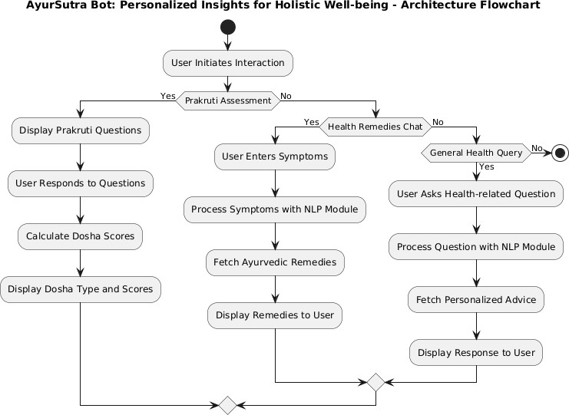

Data Flow & Process Flow Diagram

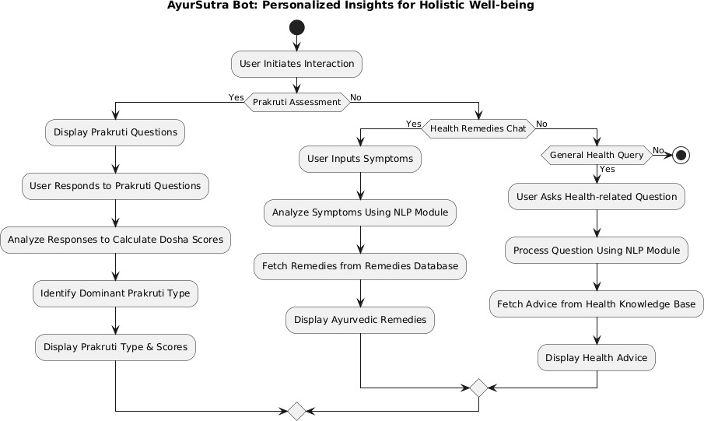

    - Class Diagram

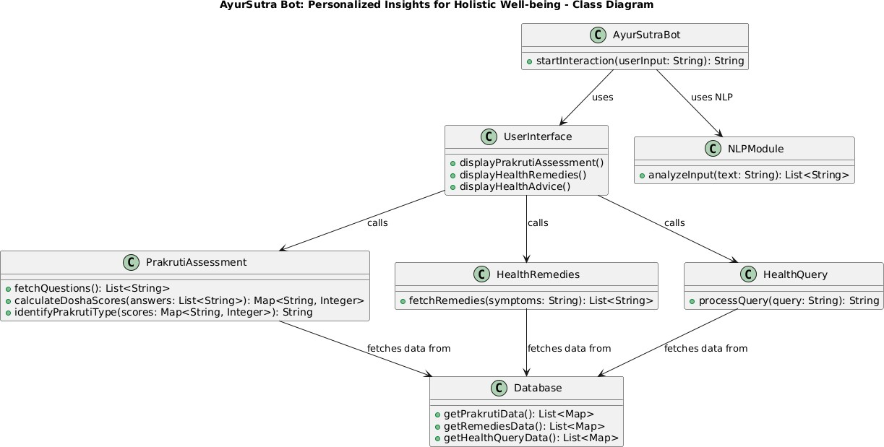

Usecase Diagram

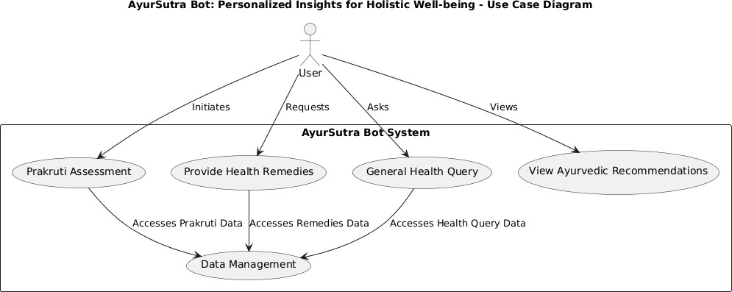

    - Sequence Diagram

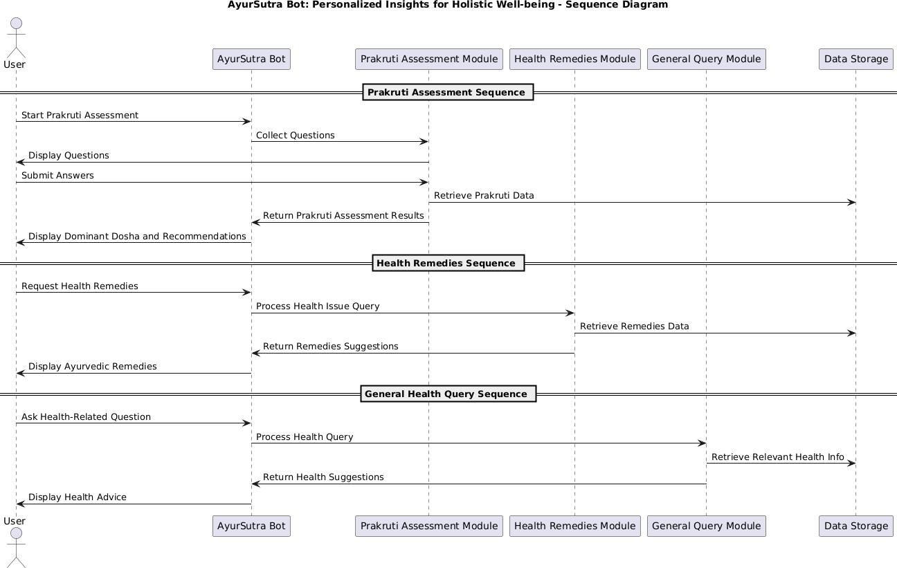

    - Activity Diagram

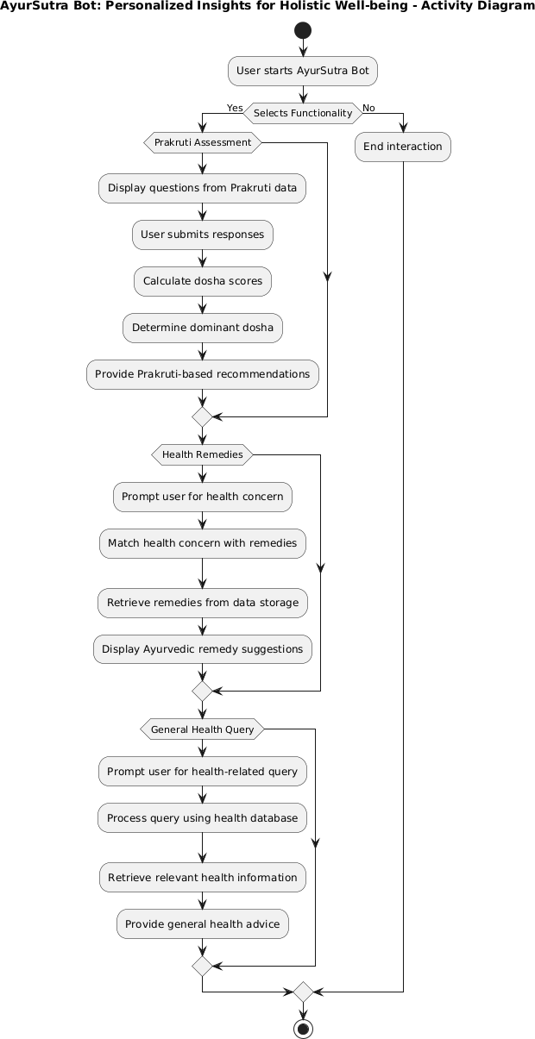

Implementation & Testing

  - Coding Blocks
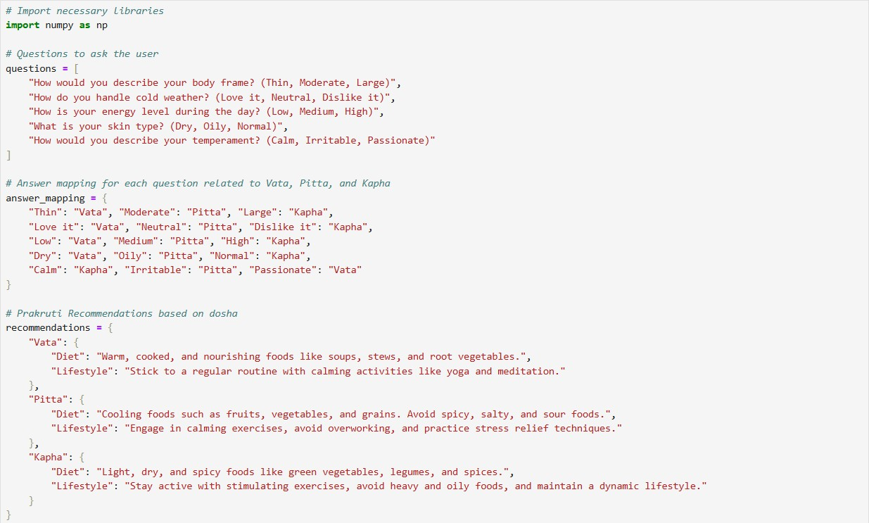
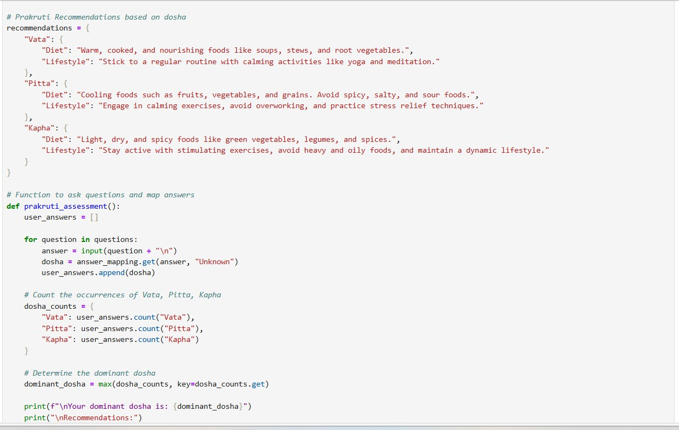

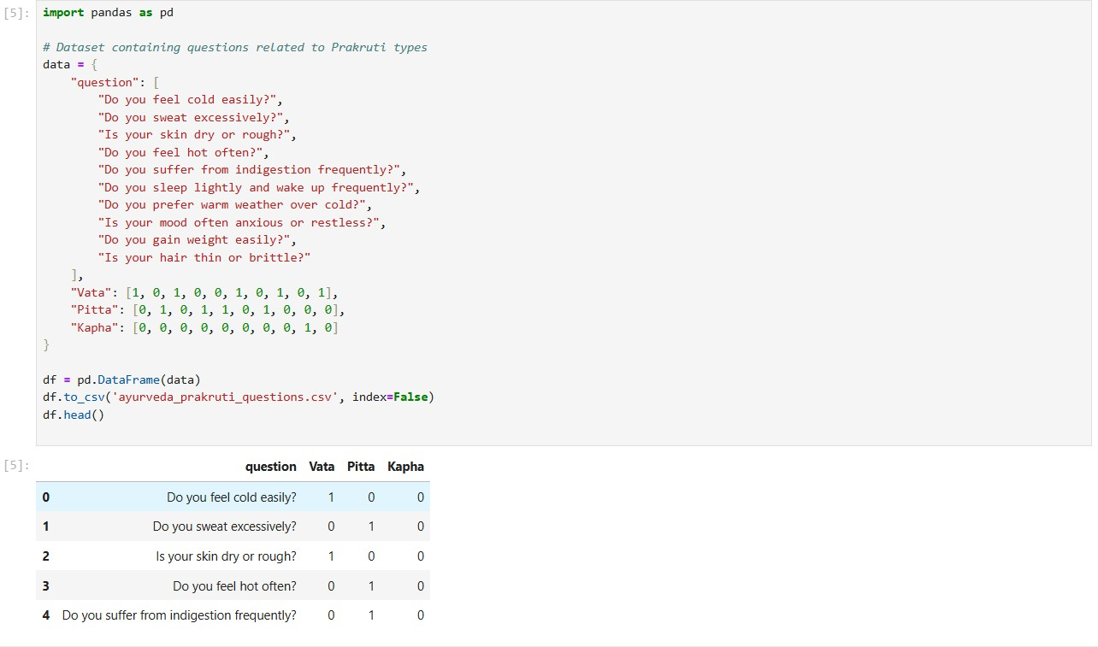

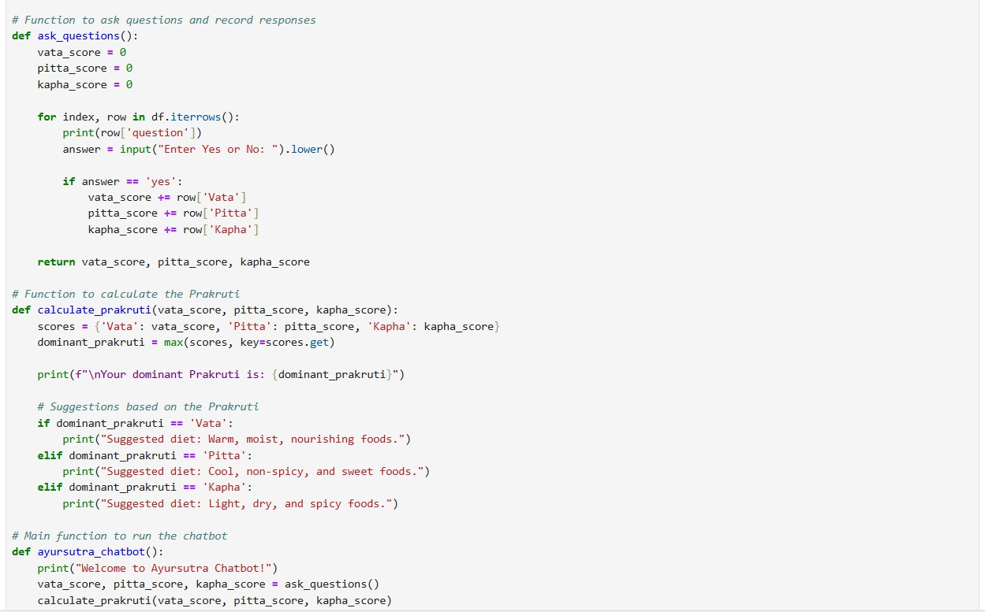

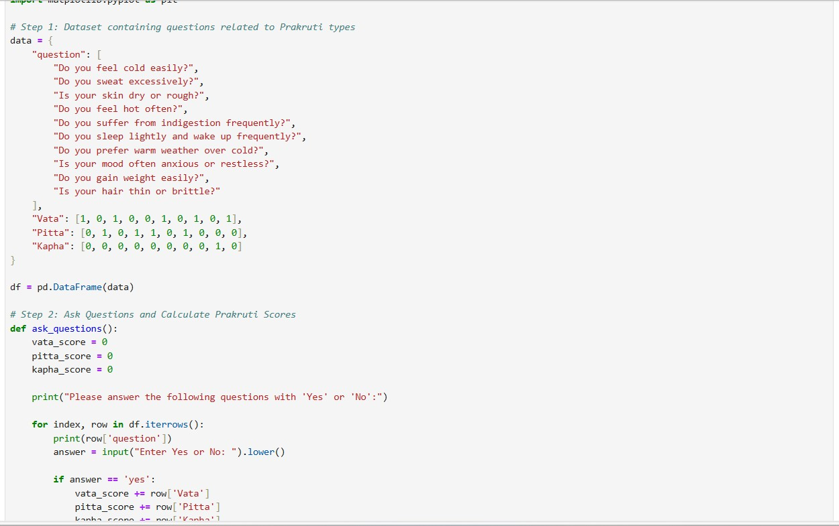

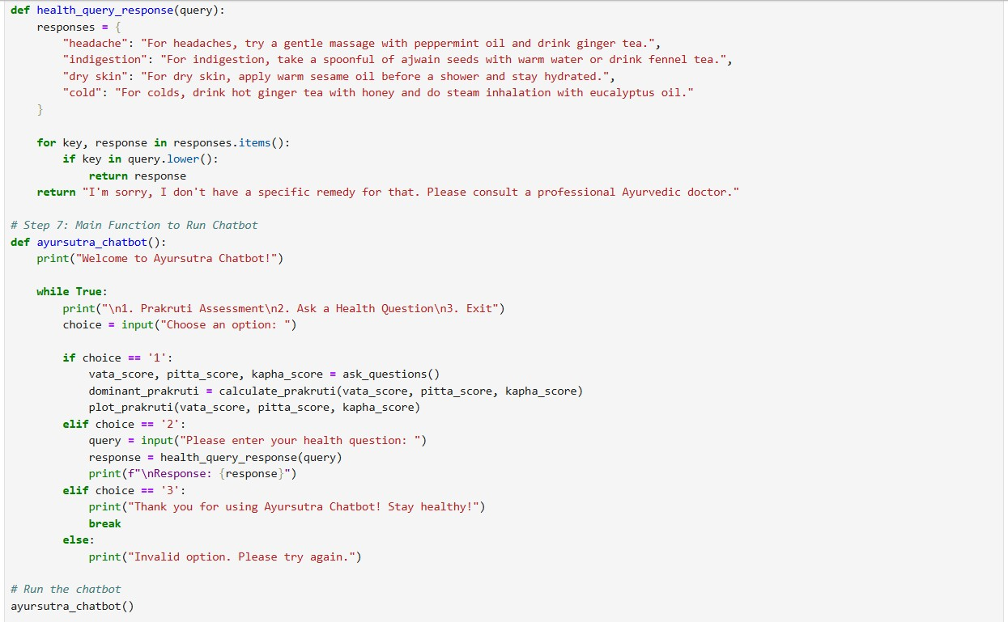

  - Sample Code

# Import necessary libraries import numpy as np

# Questions to ask the user questions = [
"How would you describe your body frame? (Thin, Moderate, Large)", "How do you handle cold weather? (Love it, Neutral, Dislike it)", "How is your energy level during the day? (Low, Medium, High)", "What is your skin type? (Dry, Oily, Normal)",
"How would you describe your temperament? (Calm, Irritable, Passionate)"
]

# Answer mapping for each question related to Vata, Pitta, and Kapha answer_mapping = {
"Thin": "Vata", "Moderate": "Pitta", "Large": "Kapha",
"Love it": "Vata", "Neutral": "Pitta", "Dislike it": "Kapha",
"Low": "Vata", "Medium": "Pitta", "High": "Kapha",
"Dry": "Vata", "Oily": "Pitta", "Normal": "Kapha",
"Calm": "Kapha", "Irritable": "Pitta", "Passionate": "Vata"
}

# Prakruti Recommendations based on dosha recommendations = {
"Vata": {
"Diet": "Warm, cooked, and nourishing foods like soups, stews, and root vegetables.", "Lifestyle": "Stick to a regular routine with calming activities like yoga and meditation."
},
"Pitta": {
"Diet": "Cooling foods such as fruits, vegetables, and grains. Avoid spicy, salty, and sour foods.",
"Lifestyle": "Engage in calming exercises, avoid overworking, and practice stress relief

techniques."
},
"Kapha": {
"Diet": "Light, dry, and spicy foods like green vegetables, legumes, and spices.",
"Lifestyle": "Stay active with stimulating exercises, avoid heavy and oily foods, and maintain a dynamic lifestyle."
}
}

# Function to ask questions and map answers def prakruti_assessment():
user_answers = []

for question in questions:
answer = input(question + "\n")
dosha = answer_mapping.get(answer, "Unknown") user_answers.append(dosha)

# Count the occurrences of Vata, Pitta, Kapha dosha_counts = {
"Vata": user_answers.count("Vata"), "Pitta": user_answers.count("Pitta"), "Kapha": user_answers.count("Kapha")
}

# Determine the dominant dosha
dominant_dosha = max(dosha_counts, key=dosha_counts.get)

print(f"\nYour dominant dosha is: {dominant_dosha}") print("\nRecommendations:")
for key, value in recommendations[dominant_dosha].items(): print(f"{key}: {value}")

# Call the assessment function to run the program prakruti_assessment()
import pandas as pd

# Dataset containing questions related to Prakruti types data = {
"question": [
"Do you feel cold easily?", "Do you sweat excessively?", "Is your skin dry or rough?", "Do you feel hot often?",
"Do you suffer from indigestion frequently?", "Do you sleep lightly and wake up frequently?", "Do you prefer warm weather over cold?",
"Is your mood often anxious or restless?", "Do you gain weight easily?",
"Is your hair thin or brittle?"
],
"Vata": [1, 0, 1, 0, 0, 1, 0, 1, 0, 1],
"Pitta": [0, 1, 0, 1, 1, 0, 1, 0, 0, 0],
"Kapha": [0, 0, 0, 0, 0, 0, 0, 0, 1, 0]
}

df = pd.DataFrame(data) df.to_csv('ayurveda_prakruti_questions.csv', index=False) df.head()
import pandas as pd
from sklearn.preprocessing import LabelEncoder

# Load the dataset
df = pd.read_csv('ayurveda_prakruti_questions.csv')

# Function to ask questions and record responses

def ask_questions(): vata_score = 0
pitta_score = 0
kapha_score = 0

for index, row in df.iterrows(): print(row['question'])
answer = input("Enter Yes or No: ").lower()

if answer == 'yes': vata_score += row['Vata'] pitta_score += row['Pitta']
kapha_score += row['Kapha']
return vata_score, pitta_score, kapha_score # Function to calculate the Prakruti
def calculate_prakruti(vata_score, pitta_score, kapha_score):
scores = {'Vata': vata_score, 'Pitta': pitta_score, 'Kapha': kapha_score} dominant_prakruti = max(scores, key=scores.get)

print(f"\nYour dominant Prakruti is: {dominant_prakruti}")

# Suggestions based on the Prakruti if dominant_prakruti == 'Vata':
print("Suggested diet: Warm, moist, nourishing foods.") elif dominant_prakruti == 'Pitta':
print("Suggested diet: Cool, non-spicy, and sweet foods.") elif dominant_prakruti == 'Kapha':
print("Suggested diet: Light, dry, and spicy foods.")

# Main function to run the chatbot def ayursutra_chatbot():

print("Welcome to Ayursutra Chatbot!")
vata_score, pitta_score, kapha_score = ask_questions() calculate_prakruti(vata_score, pitta_score, kapha_score)

# Run the chatbot ayursutra_chatbot()
import matplotlib.pyplot as plt

def plot_prakruti(vata_score, pitta_score, kapha_score): labels = ['Vata', 'Pitta', 'Kapha']
scores = [vata_score, pitta_score, kapha_score]

plt.bar(labels, scores, color=['blue', 'red', 'green']) plt.xlabel('Dosha Types')
plt.ylabel('Scores')
plt.title('Prakruti Assessment Result') plt.show()

# Call the function after getting scores
vata_score, pitta_score, kapha_score = 3, 5, 2 # Example scores, replace with actual results plot_prakruti(vata_score, pitta_score, kapha_score)
import pandas as pd
import matplotlib.pyplot as plt

# Step 1: Dataset containing questions related to Prakruti types data = {
"question": [
"Do you feel cold easily?", "Do you sweat excessively?", "Is your skin dry or rough?", "Do you feel hot often?",
"Do you suffer from indigestion frequently?", "Do you sleep lightly and wake up frequently?",

"Do you prefer warm weather over cold?", "Is your mood often anxious or restless?", "Do you gain weight easily?",
"Is your hair thin or brittle?"
],
"Vata": [1, 0, 1, 0, 0, 1, 0, 1, 0, 1],
"Pitta": [0, 1, 0, 1, 1, 0, 1, 0, 0, 0],
"Kapha": [0, 0, 0, 0, 0, 0, 0, 0, 1, 0]
}

df = pd.DataFrame(data)

import nltk
from sklearn.naive_bayes import MultinomialNB import numpy as np

# Download NLTK stopwords nltk.download('stopwords')

# Questions to ask the user questions = [
"How would you describe your body frame? (Thin, Moderate, Large)", "How do you handle cold weather? (Love it, Neutral, Dislike it)", "How is your energy level during the day? (Low, Medium, High)", "What is your skin type? (Dry, Oily, Normal)",
"How would you describe your temperament? (Calm, Irritable, Passionate)"
]

# Answer mapping for each question related to Vata, Pitta, and Kapha answer_mapping = {
"Thin": "Vata", "Moderate": "Pitta", "Large": "Kapha",
"Love it": "Vata", "Neutral": "Pitta", "Dislike it": "Kapha",
"Low": "Vata", "Medium": "Pitta", "High": "Kapha",

"Dry": "Vata", "Oily": "Pitta", "Normal": "Kapha",
"Calm": "Kapha", "Irritable": "Pitta", "Passionate": "Vata"
}

# Prakruti Recommendations based on dosha recommendations = {
"Vata": {
"Diet": "Warm, cooked, and nourishing foods like soups, stews, and root vegetables.", "Lifestyle": "Stick to a regular routine with calming activities like yoga and meditation."
},
"Pitta": {
"Diet": "Cooling foods such as fruits, vegetables, and grains. Avoid spicy, salty, and sour foods.",
"Lifestyle": "Engage in calming exercises, avoid overworking, and practice stress relief techniques."
},
"Kapha": {
"Diet": "Light, dry, and spicy foods like green vegetables, legumes, and spices.",
"Lifestyle": "Stay active with stimulating exercises, avoid heavy and oily foods, and maintain a dynamic lifestyle."
}
}

# Step 2: Ask Questions and Calculate Prakruti Scores def ask_questions():
vata_score = 0
pitta_score = 0
kapha_score = 0
print("Please answer the following questions with 'Yes' or 'No':") for index, row in df.iterrows():
print(row['question'])

answer = input("Enter Yes or No: ").lower()

if answer == 'yes': vata_score += row['Vata'] pitta_score += row['Pitta']
kapha_score += row['Kapha']

return vata_score, pitta_score, kapha_score

# Step 3: Provide Food, Lifestyle, and Home Remedies Based on Prakruti def suggest_remedies(prakruti):
if prakruti == 'Vata':
print("\n--- Vata Remedies ---")
print("Foods: Warm soups, cooked grains, nuts, and oils.")
print("Lifestyle: Keep warm, maintain regular routine, and avoid cold and dry environments.") print("Home Remedies: Warm milk with turmeric, ginger tea.")
elif prakruti == 'Pitta':
print("\n--- Pitta Remedies ---")
print("Foods: Cool, sweet fruits, dairy, rice, and cucumbers.")
print("Lifestyle: Avoid overheating, stay in cool environments, and avoid spicy foods.") print("Home Remedies: Aloe vera juice, cooling coconut oil massage.")
elif prakruti == 'Kapha':
print("\n--- Kapha Remedies ---")
print("Foods: Light, spicy, and warm foods, such as lentils, ginger, and garlic.") print("Lifestyle: Stay active, avoid heavy and oily foods, and practice vigorous exercise.") print("Home Remedies: Ginger tea, honey with warm water.")

# Step 4: Prakruti Calculation and Results
def calculate_prakruti(vata_score, pitta_score, kapha_score):
scores = {'Vata': vata_score, 'Pitta': pitta_score, 'Kapha': kapha_score} dominant_prakruti = max(scores, key=scores.get)

print(f"\nYour dominant Prakruti is: {dominant_prakruti}")

suggest_remedies(dominant_prakruti) return dominant_prakruti
# Step 5: Visualization
def plot_prakruti(vata_score, pitta_score, kapha_score): labels = ['Vata', 'Pitta', 'Kapha']
scores = [vata_score, pitta_score, kapha_score]

plt.bar(labels, scores, color=['blue', 'red', 'green']) plt.xlabel('Dosha Types')
plt.ylabel('Scores')
plt.title('Prakruti Assessment Result') plt.show()

# Step 6: General Health Query Handling def health_query_response(query):
responses = {
"headache": "For headaches, try a gentle massage with peppermint oil and drink ginger tea.", "indigestion": "For indigestion, take a spoonful of ajwain seeds with warm water or drink
fennel tea.",
"dry skin": "For dry skin, apply warm sesame oil before a shower and stay hydrated.", "cold": "For colds, drink hot ginger tea with honey and do steam inhalation with eucalyptus
oil."
}

for key, response in responses.items(): if key in query.lower():
return response
return "I'm sorry, I don't have a specific remedy for that. Please consult a professional Ayurvedic doctor."

# Step 7: Main Function to Run Chatbot

def ayursutra_chatbot():
print("Welcome to Ayursutra Chatbot!")

while True:
print("\n1. Prakruti Assessment\n2. Ask a Health Question\n3. Exit") choice = input("Choose an option: ")

if choice == '1':
vata_score, pitta_score, kapha_score = ask_questions()
dominant_prakruti = calculate_prakruti(vata_score, pitta_score, kapha_score) plot_prakruti(vata_score, pitta_score, kapha_score)
elif choice == '2':
query = input("Please enter your health question: ") response = health_query_response(query) print(f"\nResponse: {response}")
elif choice == '3':
print("Thank you for using Ayursutra Chatbot! Stay healthy!") break
else:
print("Invalid option. Please try again.")

# Run the chatbot ayursutra_chatbot()

# Step 1: Dataset containing questions related to Prakruti types data = {
"question": [
"Do you feel cold easily?", "Do you sweat excessively?", "Is your skin dry or rough?", "Do you feel hot often?",
"Do you suffer from indigestion frequently?", "Do you sleep lightly and wake up frequently?",

"Do you prefer warm weather over cold?", "Is your mood often anxious or restless?", "Do you gain weight easily?",
"Is your hair thin or brittle?"
],
"Vata": [1, 0, 1, 0, 0, 1, 0, 1, 0, 1],
"Pitta": [0, 1, 0, 1, 1, 0, 1, 0, 0, 0],
"Kapha": [0, 0, 0, 0, 0, 0, 0, 0, 1, 0]
}

df = pd.DataFrame(data)

# Step 2: Ask Questions and Calculate Prakruti Scores def ask_questions():
vata_score = 0
pitta_score = 0
kapha_score = 0
print("Please answer the following questions with 'Yes' or 'No':") for index, row in df.iterrows():
print(row['question'])
answer = input("Enter Yes or No: ").lower()

if answer == 'yes': vata_score += row['Vata'] pitta_score += row['Pitta']
kapha_score += row['Kapha']

return vata_score, pitta_score, kapha_score

# Step 3: Provide Food, Lifestyle, and Home Remedies Based on Prakruti def suggest_remedies(prakruti):

if prakruti == 'Vata':
print("\n--- Vata Remedies ---")
print("Foods: Warm soups, cooked grains, nuts, and oils.")
print("Lifestyle: Keep warm, maintain regular routine, and avoid cold and dry environments.") print("Home Remedies: Warm milk with turmeric, ginger tea.")
elif prakruti == 'Pitta':
print("\n--- Pitta Remedies ---")
print("Foods: Cool, sweet fruits, dairy, rice, and cucumbers.")
print("Lifestyle: Avoid overheating, stay in cool environments, and avoid spicy foods.") print("Home Remedies: Aloe vera juice, cooling coconut oil massage.")
elif prakruti == 'Kapha':
print("\n--- Kapha Remedies ---")
print("Foods: Light, spicy, and warm foods, such as lentils, ginger, and garlic.") print("Lifestyle: Stay active, avoid heavy and oily foods, and practice vigorous exercise.") print("Home Remedies: Ginger tea, honey with warm water.")

# Step 4: Prakruti Calculation and Results
def calculate_prakruti(vata_score, pitta_score, kapha_score):
scores = {'Vata': vata_score, 'Pitta': pitta_score, 'Kapha': kapha_score} dominant_prakruti = max(scores, key=scores.get)

print(f"\nYour dominant Prakruti is: {dominant_prakruti}") suggest_remedies(dominant_prakruti)

return dominant_prakruti

import matplotlib.pyplot as plt # Step 5: Visualization
def plot_prakruti(vata_score, pitta_score, kapha_score): labels = ['Vata', 'Pitta', 'Kapha']
scores = [vata_score, pitta_score, kapha_score]

plt.bar(labels, scores, color=['blue', 'red', 'green']) plt.xlabel('Dosha Types')
plt.ylabel('Scores')
plt.title('Prakruti Assessment Result') plt.show()

# Step 6: General Health Query Handling def health_query_response(query):
responses = {
"headache": "For headaches, try a gentle massage with peppermint oil and drink ginger tea.", "indigestion": "For indigestion, take a spoonful of ajwain seeds with warm water or drink
fennel tea.",
"dry skin": "For dry skin, apply warm sesame oil before a shower and stay hydrated.", "cold": "For colds, drink hot ginger tea with honey and do steam inhalation with eucalyptus
oil."
}

for key, response in responses.items(): if key in query.lower():
return response
return "I'm sorry, I don't have a specific remedy for that. Please consult a professional Ayurvedic doctor."

# Step 7: Main Function to Run Chatbot def ayursutra_chatbot():
print("Welcome to Ayursutra Chatbot!")

while True:
print("\n1. Prakruti Assessment\n2. Ask a Health Question\n3. Exit") choice = input("Choose an option: ")

if choice == '1':
vata_score, pitta_score, kapha_score = ask_questions()

dominant_prakruti = calculate_prakruti(vata_score, pitta_score, kapha_score) plot_prakruti(vata_score, pitta_score, kapha_score)
elif choice == '2':
query = input("Please enter your health question: ") response = health_query_response(query) print(f"\nResponse: {response}")
elif choice == '3':
print("Thank you for using Ayursutra Chatbot! Stay healthy!") break
else:
print("Invalid option. Please try again.")

# Run the chatbot ayursutra_chatbot()

  - Execution Flow

Data Collection and Preparation
    - Load and preprocess two key datasets:
      - Prakruti Data: Questions for assessing users' Prakruti type (Vata, Pitta, or Kapha).
      - Health Remedies Data: Ayurvedic remedies for specific health concerns.

User Interface Setup
    - Build a user-friendly interface using Streamlit:
      - Home Screen: Presents options for “Prakruti Assessment” or “Health Remedies Chat”.
      - Sidebar Menu: Allows users to select a feature and navigate easily.

Prakruti Assessment Module
    - Display assessment questions one-by-one.
    - Gather user responses and calculate scores for each dosha based on predefined weightings.
    - Visualize the scores through a bar chart, helping users understand their Prakruti type.
    - Display the dominant dosha as the user’s Prakruti assessment result.

Health Remedies Chat Module
    - Capture user inputs describing health symptoms or conditions.
    - Match the user's input to relevant health concerns in the remedies dataset.
    - Provide Ayurvedic remedies as responses, suggesting lifestyle changes or herbal solutions based on the matched health condition.

Machine Learning Integration (Future Scope)
    - Integrate machine learning for more personalized Prakruti prediction based on user profiles and past health data.
    - Develop a recommendation system to improve remedy suggestions by analyzing user feedback and preferences.

Error Handling and Feedback Collection
    - Implement error handling for unmatched health queries or data loading issues.
    - Provide feedback options for users to improve responses and suggestions.

Testing and Validation
    - Run test cases for each functionality:
      - Prakruti Assessment accuracy.
      - Health remedy suggestion relevance.
    - Adjust algorithms and weightings based on test results for improved performance.

Deployment and User Access
    - Host the chatbot online using Streamlit's sharing service or a cloud platform.
    - Enable easy access through a web link, ensuring compatibility across devices.

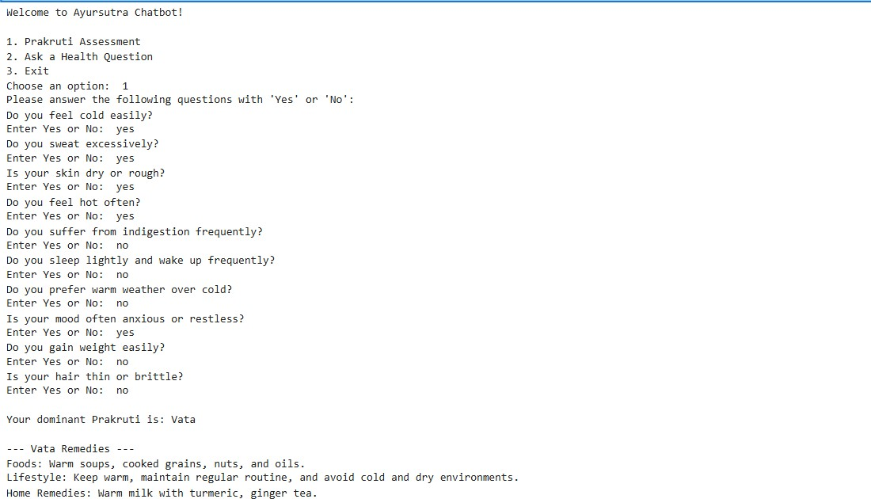

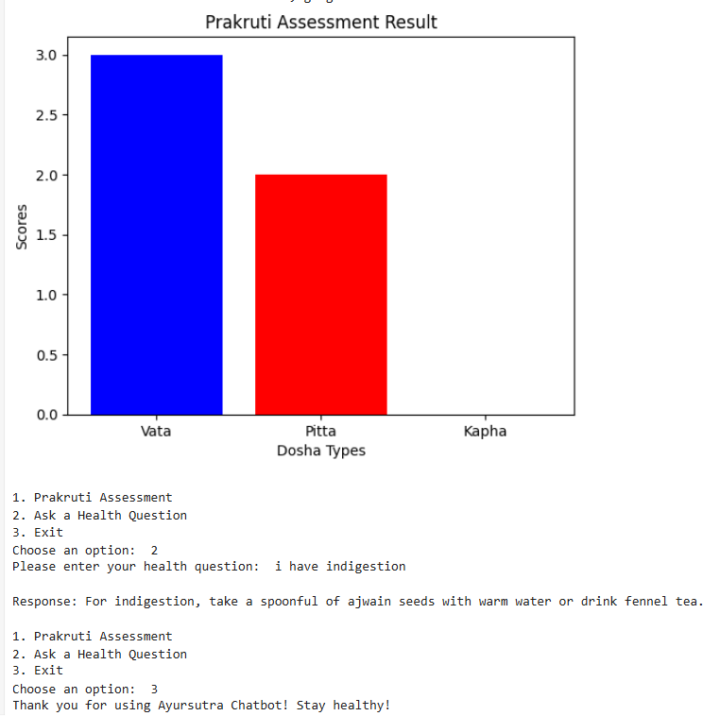

Test Cases:

    - Test Case 1: Prakruti Assessment

This test case focuses on initiating the Prakruti Assessment functionality of the AyurSutra Bot. The user is expected to log in and select the "Prakruti Assessment" option from the main interface. Upon selection, the system should prompt the user with a series of questions related to their physical, mental, and emotional characteristics, which will help in determining their dominant dosha (Vata, Pitta, or Kapha). The user is required to respond to these questions with "Yes" or "No" based on their personal traits. The expected output of this test case is the proper initialization of the assessment, displaying the questions in a clear, readable format, and ensuring that users can navigate through them without any errors. This step is critical for assessing the user's body type or Prakruti, which is the foundation for personalized Ayurvedic recommendations in the system.

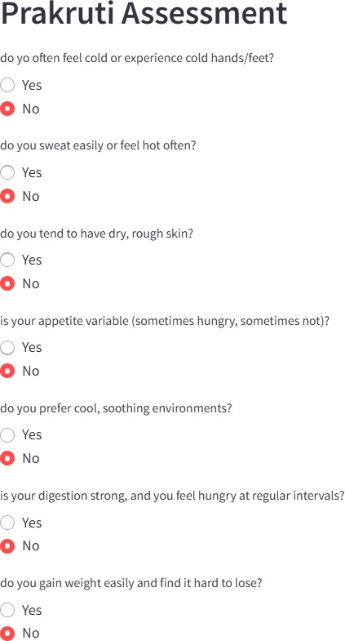

Test Case 2: Graphical Representation of Prakruti Assessment Dominant Dosha

The Graphical Representation of Prakruti Assessment Dominant Dosha visually displays the scores for each dosha (Vata, Pitta, and Kapha) after a user completes the Prakruti assessment. This representation is designed to make it easier for users to understand their dominant Prakruti type. Once the user answers the assessment questions, the system calculates scores for each dosha based on the user's responses. These scores are then plotted on a bar chart, where each bar represents one dosha and its associated score. The dominant dosha, or the dosha with the highest score, is highlighted or marked to indicate the user's primary Prakruti type. This visual feedback helps users better understand their Ayurvedic constitution and provides clear, intuitive insights into their dosha imbalances. The graphical representation also enhances the user experience by making the results more interactive and accessible.

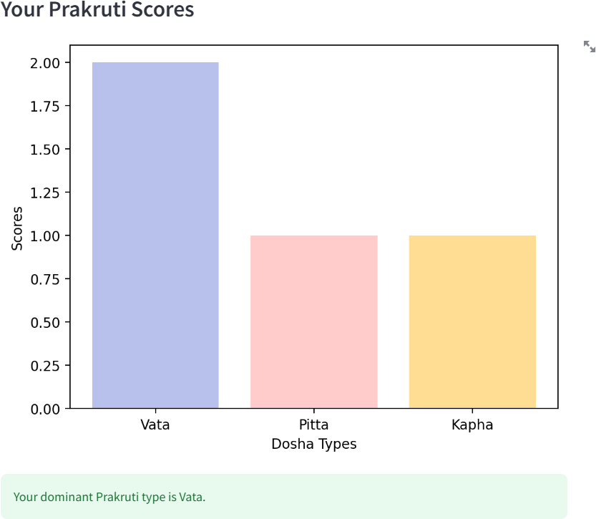

    - Test Case 3: Health Remedies Chat

The Health Remedies Chat test case is designed to evaluate the chatbot's ability to handle and respond to user queries about health issues by providing appropriate Ayurvedic remedies. Users can type in their health concerns or symptoms, and the chatbot should process the input to provide relevant suggestions based on the health remedies dataset.

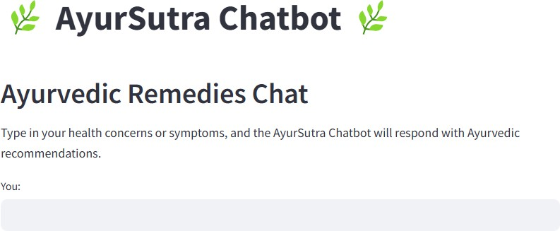

Conclusions & Future Scope

  - References

    - C Sharma, P. V. (1996). "Classical Uses of Medicinal Plants." Chaukhambha Visvabharati, Varanasi. (Traditional Ayurvedic text) A key reference for understanding the traditional use of Ayurvedic plants, which plays a foundational role in providing remedies in the project.
    - Sharma, P. (2006). "Principles of Ayurveda: A Comprehensive Guide to Ayurvedic Medicine." Ayurvedic Publications.This book provides an in-depth exploration of Ayurvedic principles, which are essential for building a knowledge base for the chatbot to suggest holistic remedies.
    - Kumar, A., & Singh, P. (2018). "Role of Ayurveda in Personalized Medicine." Journal of Ayurveda and Integrative Medicine, 9(4), 243-248. DOI: 10.1016/j.jaim.2018.08.002 This article discusses the integration of Ayurveda with modern medicine and the concept of personalized healthcare, which aligns with the project's focus on personalized Ayurvedic advice.
    - Wang, X., et al. (2019). "Machine Learning for Healthcare: Review, Opportunities, and Threats." ACM Computing Surveys, 54(1), 1-35. DOI: 10.1145/3287568. This paper reviews machine learning applications in healthcare, providing valuable insights into the potential and challenges of using machine learning for personalized health interventions, which is central to the project.
    - Jiang, F., et al. (2017). "Artificial Intelligence in Healthcare: Anticipating Challenges to Ethics, Privacy, and Bias." Health Affairs, 36(11), 1916-1922. DOI: 10.1377/hlthaff.2017.0840. This article explores ethical considerations and challenges in using AI in healthcare, relevant to addressing concerns in the development of the AyurSutra Chatbot.
    - Gonzalez, A., & Pujol, F. (2020). "Natural Language Processing for Healthcare: A Review of Applications." Journal of Biomedical Informatics, 109, 103532. DOI: 10.1016/j.jbi.2020.103532. This paper highlights the use of Natural Language Processing (NLP) in healthcare, which is a core component of the chatbot’s ability to understand and respond to health queries.
    - Rani, S., & Rani, S. (2020). "Application of Machine Learning Techniques in Healthcare: A

Review." International Journal of Healthcare Information Systems and Informatics, 15(2), 1-
18. DOI: 10.4018/IJHISI.2020040101. This paper reviews the use of machine learning techniques in healthcare applications, providing useful methodologies and case studies that can inform the design of the project.
    - Hinton, G. E., et al. (2006). "Reducing the Dimensionality of Data with Neural Networks." Science, 313(5786), 504-507. DOI: 10.1126/science.1127647. A foundational paper on deep learning techniques, which could be applied to process and classify health-related data effectively in the project.
    - Kumar, V., et al. (2019). "Role of Data Analytics in Personalized Healthcare: An Overview." Healthcare, 7(1), 1-9. DOI: 10.3390/healthcare7010001. This article provides an overview of data analytics in personalized healthcare, reinforcing the data-driven approach in providing tailored Ayurvedic insights in your project.
    - Soni, A., & Sharma, A. (2021). "Ayurveda and Machine Learning: A Synergy for Personalized Healthcare." Journal of Computational Medicine, 3(2), 32-47. This recent paper explores the intersection of Ayurveda and machine learning, suggesting methods for developing systems like the AyurSutra Bot for personalized health recommendations based on Ayurvedic principles.

  - Future scope

The future scope of the AyurSutra Bot: Personalized Insights for Holistic Well-being is vast, with numerous possibilities for expansion and improvement. One significant future development is the integration of wearable health devices and mobile applications. This would allow the bot to collect real-time data on a user's physical activity, sleep patterns, heart rate, and other vital signs. By leveraging this data, the bot can provide even more personalized health recommendations and make real-time adjustments to a user's lifestyle suggestions. This feature would not only enhance the bot’s ability to offer proactive health advice but also create a seamless experience for users, making it easier to track and maintain their health.

The project also has the potential for expansion into different wellness domains, such as mental health, stress management, and chronic disease management. By integrating Ayurvedic principles with modern wellness strategies, the bot could offer guidance on topics like emotional
well-being, mindfulness practices, and managing long-term conditions such as diabetes,

hypertension, or arthritis. Additionally, the system could be expanded to provide support for

individuals with specific health goals, such as weight loss, improving digestion, or boosting immunity. This broader scope would appeal to a wider audience and offer more diverse benefits, making it a comprehensive health companion.

The future scope of the AyurSutra Bot: Personalized Ayurvedic Insights for Holistic Well-being project offers several exciting opportunities for enhancement and broader application. One significant direction for future development is the integration with wearable devices. As wearable health technologies like fitness trackers and smartwatches become more widespread, integrating these devices with the chatbot could allow for real-time health monitoring. Information such as heart rate, blood pressure, and activity levels could be fed into the system, enabling the chatbot to offer dynamic, personalized recommendations based on the user’s current health data.

Integration with Wearable Devices:
The chatbot could integrate with wearable health technologies (e.g., fitness trackers, smartwatches) to provide real-time health monitoring. This integration would allow the bot to analyze data such as heart rate, sleep patterns, and activity levels, offering more dynamic and personalized health advice.

Voice Assistant Integration:
Adding voice recognition capabilities would allow users to interact with the bot using voice commands, making the system more accessible and user-friendly. This could enhance the user experience, especially for those who prefer voice interaction over text.

Expansion of Data Repository:
The chatbot could benefit from incorporating a wider range of Ayurvedic resources, such as research papers and case studies. This would help improve the depth and accuracy of the advice provided, offering more specific solutions to a broader array of health concerns.

Multi-Language Support:
Expanding the chatbot to support multiple languages would make it accessible to a wider audience globally. This feature would allow non-English speakers to benefit from Ayurvedic

guidance, promoting holistic health across different cultures.

Personalized Ayurvedic Diet Plan Generator:
By using real-time user data, the chatbot could generate dynamic, personalized diet plans tailored to the user's Prakruti, health condition, and environmental factors. This would ensure the advice remains relevant and effective throughout different seasons and health phases.

Real-Time Health Monitoring and Feedback:
The chatbot could track users' health data and provide immediate feedback or recommendations based on changes in lifestyle, diet, or emotional state. This would allow users to receive proactive suggestions, helping them maintain better health and prevent problems.

Collaboration with Ayurvedic Experts:
Incorporating consultations with certified Ayurvedic practitioners would increase the bot’s credibility and provide users with personalized, professional advice. This could create an opportunity for users to interact with experts for deeper insights into their health.

Mental Health Support Integration:
The chatbot could also offer support for mental well-being by suggesting Ayurvedic remedies for stress, anxiety, and emotional balance. This addition would provide users with a comprehensive solution for both physical and mental health.

Integration with Medical Health Records:
By linking the chatbot with users' medical records, it could offer advice that complements their current treatments and conditions. This would enable more personalized and accurate health recommendations, tailored to the user’s medical history.

Social Features for Community Engagement:
Introducing social features could allow users to share their experiences, remedies, and progress with others. This would help create a supportive community, fostering an environment where users can learn from and motivate each other on their health journeys.

  - Result

The AyurSutra Bot: Personalized Insights for Holistic Well-being project has successfully demonstrated the potential of combining traditional Ayurvedic knowledge with modern machine learning algorithms to provide personalized health insights. The chatbot, based on the user’s Prakruti (Ayurvedic body constitution), delivers personalized recommendations related to diet, lifestyle, and remedies, offering a holistic approach to health management.

The Prakruti assessment functionality effectively analyzes user responses to a series of health- related questions, determining their dominant dosha (Vata, Pitta, or Kapha). Based on the identified Prakruti, the bot generates tailored suggestions that help users maintain balance within their bodies and minds. These recommendations are based on the principles of Ayurveda, ensuring they are natural, safe, and personalized to each individual's needs.

The health remedies feature of the chatbot offers guidance on managing common health issues such as headaches, indigestion, and stress, based on Ayurvedic treatments. It provides users with holistic remedies like herbal solutions, yoga asanas, and dietary suggestions that are aligned with their body type and current health condition. This feature has proven effective in promoting preventive care and overall wellness.

The project has successfully integrated natural language processing (NLP) to allow users to interact with the bot in a conversational manner, making it user-friendly and accessible. The chatbot’s ability to understand and respond to health-related queries in real time adds immense value, helping users receive advice quickly and efficiently.

Moreover, the web-based interface developed for the project ensures that users can access the chatbot easily, without needing to install complex software. The design is simple yet effective, offering a clean and intuitive layout that guides users through the process of assessing their Prakruti and receiving health recommendations.

Overall, the AyurSutra Bot project has achieved its goal of merging ancient Ayurvedic wisdom with modern machine learning technology. It provides an innovative tool for individuals seeking personalized, holistic health guidance, and serves as a potential foundation for further research and development in the field of AI-driven wellness applications.

The chatbot functionality also proves effective, providing users with answers to their health-related queries in real-time. It helps users make informed decisions about their well-being by leveraging Ayurveda’s principles, such as balancing the doshas to improve overall health. The integration of machine learning models ensures that the recommendations are tailored to individual needs, improving as more data is collected. Additionally, the graphical representations of the Prakruti assessment and health remedies are user-friendly, enhancing the overall experience.







  - Conclusion

In conclusion, the AyurSutra Bot: Personalized Insights for Holistic Well-being project represents a novel approach to merging traditional Ayurvedic knowledge with cutting-edge artificial intelligence technologies. By utilizing machine learning algorithms, the project successfully creates a system that offers personalized health assessments based on individual Prakruti (body constitution). Through a series of diagnostic questions, the bot calculates the user’s dosha dominance (Vata, Pitta, or Kapha) and provides tailored advice regarding diet, lifestyle, and physical activities. This ensures that the recommendations are highly specific and grounded in the Ayurvedic principles that have been practiced for thousands of years, offering users a holistic path to wellness.

The AyurSutra Bot also includes a healthremedies feature that responds to user queries related to common health concerns, offering Ayurvedic solutions, treatments, and preventive measures. By using an extensive dataset of health conditions and corresponding remedies, the bot is able to provide users with practical, accessible advice. This dual function—both Prakruti assessment and health advice—sets the bot apart from conventional health apps, as it provides a deeper, more personalized approach to well-being. The integration of AI ensures that the bot can continually learn from user interactions, improving its responses and accuracy over time, while also providing an engaging, interactive experience.

One of the significant strengths of the AyurSutra Bot is its ability to make ancient Ayurvedic knowledge accessible to modern users in a convenient, digital format. The user-friendly interface, which includes a simple and intuitive chatbot design, ensures that even users without any prior knowledge of Ayurveda can easily navigate the system and benefit from the advice provided. This makes the AyurSutra Bot not just a tool for health advice but also an educational platform for users to learn about Ayurveda in a dynamic way. Additionally, by providing personalized health insights, the bot helps users make informed decisions about their daily habits, thus fostering long-term health improvements.

Despite its successes, the AyurSutra Bot has potential for further enhancement. Future developments could include expanding its database of Ayurvedic remedies and integrating more advanced machine learning techniques to provide even more accurate recommendations based on user data. Moreover, the bot could be adapted for use in different cultural contexts, with personalized health advice tailored to specific regional health needs. By incorporating feedback loops and

additional data from users, the system can evolve to offer even more nuanced and comprehensive health guidance. This continued growth would ensure that the AyurSutra Bot remains relevant and valuable as a health and wellness tool for years to come.

Overall, the project signifies a promising step forward in the field of personalized health and wellness. It bridges the gap between ancient Ayurvedic wisdom and the technological advancements of today, providing users with a unique and meaningful tool for managing their health. The AyurSutra Bot not only holds the potential to transform how people approach their well-being but also contributes to the growing movement of using AI to enhance traditional practices, ensuring that these practices continue to thrive in the modern world. With future refinements and continuous updates, the AyurSutra Bot could become an indispensable part of everyday health management, fostering holistic well-being for users globally.

PAPER PUBLICATION

AYURSUTRA BOT:

PERSONALIZED INSIGHTS FOR HOLISTIC WELL-BEING

T.Suneetha¹, Divya Pagadala²
¹Assistant Professor, Department of Computer Science & Engineering – CyberSecurity&IoT,
¹thanduri_suneetha@mallareddyuniversity.ac.in

²Student, Department of Computer Science & Engineering – IoT, . 2211cs050081@mallareddyuniversity.ac.in
^{1,2}Malla Reddy University, Hyderabad, Telangana, India

Abstract—The AyurSutra Bot is an AI-driven chatbot that revolutionizes the traditional Ayurvedic practice of Prakruti assessment through advanced machine learning and natural language processing (NLP) techniques. With Ayurveda’s holistic health philosophy, individuals are categorized into Prakruti types—Vata, Pitta, and Kapha—which guide personalized lifestyle and dietary recommendations. However, conventional Prakruti assessments are often lengthy, subjective, and challenging to access widely. The AyurSutra Bot overcomes these limitations by offering a seamless, user- friendly chatbot interface, where users can determine their Prakruti type via a structured questionnaire. Utilizing NLP to interpret responses and a machine learning model grounded in Ayurvedic principles, the bot provides precise Prakruti predictions. It then delivers tailored health guidance based on the user’s constitution, making Ayurvedic insights accessible, consistent, and scalable. Bridging ancient Ayurvedic wisdom with modern technology, the AyurSutra Bot offers an efficient, automated approach to holistic well-being that aligns with the demands of today’s fast-paced world. The AyurSutra Bot project introduces an intelligent chatbot designed to bring the traditional Ayurvedic method of Prakruti (constitution) assessment into the digital age. By leveraging machine learning algorithms and natural language processing (NLP) techniques, this innovative system automates the identification of an individual's Prakruti type—Vata, Pitta, or Kapha. Ayurveda, an ancient holistic health system, emphasizes personalized care based on these constitution types. However, conventional assessments are often subjective and require substantial time and expertise, limiting their accessibility. The AyurSutra Bot tackles these challenges by using a structured questionnaire and NLP-driven analysis to understand users’ responses, seamlessly guiding them through the process in a convenient and user- friendly manner. Once the assessment is complete, the bot delivers customized recommendations, including diet, lifestyle adjustments, and simple remedies aligned with the user’s unique constitution. This project demonstrates how modern AI can bridge the gap between traditional wisdom and current technological needs, making Ayurvedic guidance readily available, scientifically grounded, and more adaptable to today’s fast-paced lifestyles. In doing so, the AyurSutra Bot aims to enhance well-being and promote a personalized approach to health that remains true to Ayurveda’s timeless principles.
Keywords—Ayurveda, Prakruti assessment, Vata, Pitta, Kapha, Machine learning, Personalized health recommendations, Natural Language Processing(NLP), Ancient health practices, Automated Prakruti analysis, AyurSutra Bot, Holistic health, Dietary advice.

Introduction
The AyurSutra Bot is a groundbreaking project that combines the ancient principles of Ayurveda with the power of artificial intelligence to provide personalized health guidance. Rooted in Ayurveda’s approach to wellness, which categorizes individuals by their Prakruti type—Vata, Pitta, or Kapha—this project aims to make personalized health insights accessible, efficient, and adaptable for modern users. Traditional Prakruti assessments are often complex, requiring significant time and expertise, which can limit their accessibility. The AyurSutra Bot addresses these limitations by using machine learning and natural language processing (NLP) to automate the Prakruti determination process. Through a user-friendly chatbot interface, individuals complete a structured questionnaire, after which the bot uses advanced algorithms to predict their unique constitution. Following this, users receive tailored lifestyle, dietary, and wellness recommendations aligned with their Prakruti type, promoting holistic well-being. By merging ancient Ayurvedic wisdom with advanced technology, the AyurSutra Bot brings the benefits of personalized Ayurvedic guidance to a wider audience, meeting the needs of today’s fast-paced lifestyle while honoring the integrity of Ayurveda’s holistic health principles. The AyurSutra Bot represents an innovative fusion of ancient Ayurvedic practices and modern artificial intelligence, designed to streamline and enhance the traditional Prakruti assessment process. Ayurveda, an ancient system of holistic health,

emphasizes that each person has a unique constitution—known as Prakruti—which aligns with one or a combination of three primary doshas: Vata, Pitta, and Kapha. This Prakruti impacts an individual’s physical, mental, and emotional health, making personalized wellness guidance central to maintaining balance and well-being. However, traditional Prakruti assessments often require expert consultation and can be lengthy, making them less accessible in today’s fast- paced world.
The AyurSutra Bot project is an advanced AI-based initiative designed to modernize the ancient Ayurvedic practice of Prakruti assessment, bringing personalized health guidance to a global audience in a streamlined, accessible format. Rooted in Ayurveda, this system focuses on understanding and harmonizing the body’s unique constitution, classified into three primary doshas: Vata, Pitta, and Kapha. Each dosha reflects distinct physical, mental, and emotional characteristics, guiding individualized lifestyle, dietary, and wellness recommendations to promote balance and prevent illness. However, traditional methods of Prakruti assessment can be subjective, time-intensive, and reliant on expert analysis, often limiting their availability to those with access to Ayurvedic practitioners. The AyurSutra Bot overcomes these limitations by integrating machine learning and natural language processing (NLP) to digitize and standardize the Prakruti assessment process. The chatbot interface enables users to answer a series of carefully structured questions designed to capture the nuances of their constitution. By applying NLP, the bot interprets users’ inputs, while a machine learning model—trained on a robust dataset rooted in Ayurvedic principles—predicts their Prakruti type with consistency and precision. Once the assessment is completed, the bot delivers actionable, personalized health advice aligned with each user’s dosha type, including dietary guidance, lifestyle adjustments, home remedies, and even specific yogic practices. This digital adaptation not only retains the authenticity of Ayurvedic wisdom but also provides an efficient, scalable approach to personalized wellness, making Ayurvedic insights available to individuals worldwide, regardless of their location or background. Through the AyurSutra Bot, the age-old benefits of Ayurveda meet cutting-edge technology, offering a balanced, holistic pathway to health that fits seamlessly into modern life.

Literature Survey
Sharma, P. (2006). et al. [1] In Principles of Ayurveda: A Comprehensive Guide to Ayurvedic Medicine, Dr. P. Sharma (2006) offers an in-depth exploration of Ayurvedic principles, designed as a detailed guide for both beginners and practitioners of Ayurvedic medicine. Published by Ayurvedic Publications, this book explains the philosophical foundation, diagnostic techniques, and therapeutic strategies intrinsic to Ayurveda. Dr. Sharma introduces
readers to core Ayurvedic concepts, including the three doshas (Vata, Pitta, and Kapha), the concept of Prakruti (individual constitution), and the importance of diet and lifestyle in achieving holistic health.

Kumar, A., & Singh, P. (2018). et al. [2] Kumar and Singh's (2018) article, Role of Ayurveda in Personalized Medicine, published in the Journal of Ayurveda and Integrative Medicine, explores Ayurveda’s potential contributions to personalized medicine. The authors examine how Ayurvedic principles, such as Prakruti (an individual’s unique constitution based on the balance of doshas—Vata, Pitta, and Kapha), align closely with modern concepts of individualized treatment. They propose that Ayurveda’s holistic diagnostic and therapeutic approach, rooted in the identification of each person’s physical, mental, and emotional attributes, allows for tailored healthcare that complements genetic and biomarker-based methods in modern medicine.

Wang, X., et al. (2019). et al. [3] Wang et al.'s (2019) comprehensive review, Machine Learning for Healthcare: Review, Opportunities, and Threats, published in ACM Computing Surveys, provides an extensive overview of how machine learning (ML) is transforming healthcare. The authors discuss the wide- ranging applications of ML in healthcare, including diagnostics, personalized treatment plans, predictive analytics, and the optimization of healthcare management systems. They highlight how ML techniques can analyze vast and complex datasets— like medical images, patient records, and genetic data—to enhance decision-making and improve patient outcomes.

Jiang, F., et al. (2017). et al. [4] In Artificial Intelligence in Healthcare: Anticipating Challenges to Ethics, Privacy, and Bias, Jiang et al. (2017) address critical concerns surrounding the integration of artificial intelligence (AI) in healthcare. Published in Health Affairs, this paper examines the ethical, privacy, and bias-related challenges AI poses as it increasingly supports diagnostic, therapeutic, and administrative functions in healthcare. The authors highlight AI's potential to improve healthcare accessibility and precision, but they caution that, without careful oversight, AI could exacerbate existing inequalities and pose privacy risks.

Gonzalez, A., & Pujol, F. et al. [5] The authors discuss various NLP applications in healthcare, including electronic health record (EHR) mining, automated coding, clinical decision support, and patient sentiment analysis. One prominent use case is in EHR data extraction, where NLP helps identify key insights from patient histories, treatments, and outcomes, facilitating quicker and more accurate clinical decisions. Gonzalez and Pujol highlight that NLP can enhance diagnostics and personalized treatment by integrating clinical text

data with other medical information, thereby enabling a more holistic approach to patient care.

Rani, S., & Rani, S. (2020). et al. [6] In Application of Machine Learning Techniques in Healthcare: A Review, Rani and Rani (2020) provide an extensive overview of how machine learning (ML) techniques are transforming healthcare. Published in the International Journal of Healthcare Information Systems and Informatics, the article explores various ML applications across diagnostics, treatment planning, patient monitoring, and disease prediction, emphasizing the potential of ML to enhance accuracy, efficiency, and personalization in healthcare.

Hinton, G. E., et al. (2006). et al. [7] The authors demonstrate that neural networks, specifically a type of unsupervised learning model known as autoencoders, can be used to reduce the number of features or variables in a dataset while retaining the essential information. The method they proposed uses a multi- layered neural network to learn an efficient representation (or encoding) of the data in fewer dimensions, which is then used for downstream tasks like classification or visualization. This approach has important implications for simplifying complex datasets, making them easier to interpret, and improving the performance of machine learning models by reducing overfitting and computation time.

Kumar, V., et al. (2019). [8] The paper discusses various methods of data analytics such as predictive modeling, clustering, classification, and regression analysis, which are applied to large healthcare datasets like electronic health records (EHR), medical imaging, and genomic data. These methods are instrumental in identifying trends, risk factors, and treatment outcomes that vary across different individuals, thus enabling personalized medicine. Personalized healthcare aims to provide care that is specifically suited to the patient's unique genetic makeup, lifestyle, and environmental factors, rather than relying on a "one-size-fits-all" approach.

SYSTEM ANALYSIS

Existing System
The existing system for Prakruti assessment in Ayurveda primarily relies on traditional, practitioner- led consultations. During these consultations, Ayurvedic practitioners evaluate an individual’s physical, mental, and emotional characteristics through a combination of structured questions, observational assessments, and pulse diagnosis to determine their dominant dosha or constitution type—Vata, Pitta, or Kapha. While this personalized approach allows practitioners to offer detailed insights and recommendations, it is often highly subjective and requires significant expertise, which can result in
variability between assessments. Additionally, conventional Prakruti assessments are usually time- consuming and depend on in-person consultations, limiting accessibility for individuals in remote areas or those who may not have access to qualified practitioners. Though some digital questionnaires exist for preliminary Prakruti evaluation, they are often simple, static tools that lack depth and adaptability, failing to capture the nuances of an individual’s constitution accurately. These tools are typically limited to a fixed set of questions with predefined responses, providing general guidance rather than the personalized recommendations needed to align closely with Ayurvedic principles. Furthermore, such digital questionnaires generally lack integration with machine learning and NLP capabilities, which could improve their accuracy and interactivity. As a result, the existing system lacks scalability, consistency, and efficiency, making it challenging to meet the growing demand for personalized health solutions rooted in Ayurveda. The AyurSutra Bot seeks to address these limitations by automating Prakruti assessment through AI, making it objective, accessible, and tailored to each user’s unique health profile.

Proposed System
The proposed system, the AyurSutra Bot, introduces a modernized, AI-driven solution for Prakruti assessment, making Ayurvedic insights more accurate, accessible, and personalized. This intelligent chatbot leverages machine learning and natural language processing (NLP) to assess users’ Prakruti type—Vata, Pitta, or Kapha—based on their responses to a structured questionnaire. Unlike traditional assessments, which rely on expert judgment and may vary in consistency, the AyurSutra Bot uses a machine learning model trained on Ayurvedic principles to interpret responses objectively, ensuring a more consistent and reliable assessment. Through NLP, the bot can understand and analyze user inputs dynamically, enhancing the chatbot’s ability to capture subtle nuances in users’ physical and emotional characteristics. Once the Prakruti assessment is complete, the AyurSutra Bot delivers personalized health guidance, including dietary, lifestyle, and self- care recommendations, all tailored to the individual’s dosha type. This makes the system a scalable, digital solution that maintains the integrity of Ayurveda’s holistic approach while catering to the needs of today’s fast-paced world. By automating the assessment process and integrating a conversational interface, the AyurSutra Bot aims to democratize Ayurvedic knowledge, providing an efficient, user-friendly experience that can reach a broad audience, regardless of geographical or financial barriers. The proposed system thus bridges the gap between traditional Ayurvedic wisdom and modern health technology, promoting holistic well-being through a customized,

science-backed approach that is both practical and adaptable to the lifestyles of contemporary users. The proposed AyurSutra Bot system offers a transformative approach to Ayurvedic health assessments by automating the traditionally complex process of Prakruti evaluation. Built as an AI-powered chatbot, the AyurSutra Bot enables users to interact through a structured yet dynamic question-and-answer format, allowing for a thorough assessment of physical, mental, and emotional traits that influence their Ayurvedic constitution. By integrating natural language processing (NLP), the chatbot interprets responses conversationally, making it adaptable and user- friendly. Unlike standard online quizzes, which are often rigid and lack depth, the AyurSutra Bot uses NLP to detect subtle patterns in language and expression, capturing nuances that enhance the accuracy of Prakruti classification. In addition to NLP, the proposed system leverages a machine learning model trained on a dataset aligned with Ayurvedic principles. This model enables precise prediction of the user’s Prakruti type—Vata, Pitta, or Kapha—by analyzing patterns and correlations within user data. The automation introduced by this model not only improves the consistency and objectivity of the assessment but also removes the dependency on human interpretation, thereby reducing the risk of bias. The model’s training is based on established Ayurvedic guidelines, ensuring that the predictions align with traditional wisdom while incorporating data-driven accuracy.

Advantages:

The AyurSutra Bot project brings numerous advantages by combining the timeless wisdom of Ayurveda with cutting-edge AI technology, creating a solution that is accessible, efficient, and personalized. One of the primary benefits of this system is accessibility; the AyurSutra Bot provides users with instant access to Ayurvedic insights without requiring a face-to-face consultation with a practitioner, making it a valuable tool for individuals in remote areas or those with limited access to Ayurvedic experts. Additionally, the use of machine learning and NLP ensures consistency and accuracy in Prakruti assessments, removing subjective variability and offering a reliable evaluation of each user’s constitution. This makes the assessment process more standardized and scalable, as it does not rely on human interpretation, allowing a broader reach to diverse populations. Another significant advantage is the personalized health guidance it offers. By tailoring dietary, lifestyle, and wellness recommendations to each user’s unique Prakruti, the AyurSutra Bot helps users make informed choices that support their individual health needs, promoting holistic well-being and preventing potential health issues associated with imbalances in their constitution. The convenience of a chatbot interface further enhances user experience by providing real-time, interactive support that fits
seamlessly into a busy lifestyle, making health guidance more practical and actionable. Moreover, the AyurSutra Bot preserves and modernizes Ayurvedic practices, making them relevant and appealing to contemporary users who are increasingly interested in natural and preventive healthcare solutions. By integrating Ayurveda with AI, this project brings the best of both worlds, honoring ancient health principles while adapting them for the digital age. The scalable design also allows for future updates and improvements, enabling the bot to evolve with advancements in AI and Ayurveda, ultimately offering a robust, user-centric tool for personalized holistic wellness.

Methodology

Architecture

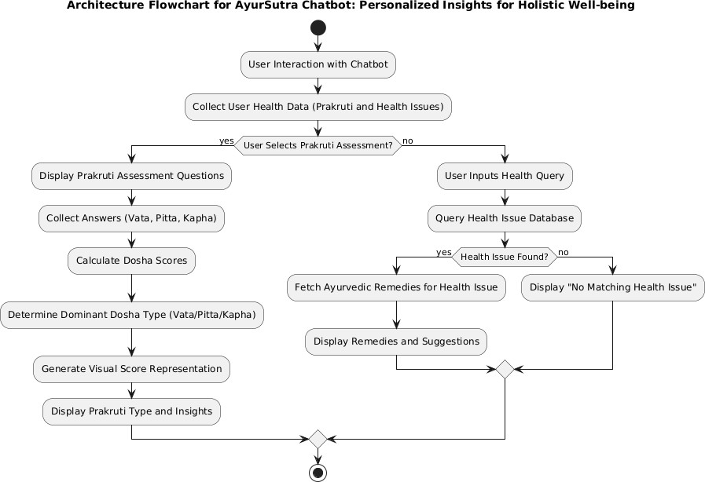
Fig 1: Architecture Diagram

The architecture flowchart of the AyurSutra Bot project outlines the systematic process through which the chatbot interacts with users and provides personalized Ayurvedic health assessments. The journey begins when a user initiates interaction with the chatbot interface, engaging in a conversational format designed to gather essential information about their physical, mental, and emotional traits. The user is then presented with a structured questionnaire that captures their

responses, which are critical for accurate Prakruti assessment. Once the user submits their answers, the chatbot employs natural language processing (NLP) to analyze and interpret the responses, allowing it to identify key patterns and relevant features. This step is crucial as it transforms user inputs into a format suitable for further analysis. Following NLP processing, the system extracts these features and inputs them into a machine learning model, which has been trained on Ayurvedic principles to predict the user's dominant dosha—Vata, Pitta, or Kapha. Upon determining the Prakruti type, the AyurSutra Bot generates personalized health recommendations tailored to the user’s specific constitution. These recommendations include actionable dietary suggestions, lifestyle adjustments, and wellness tips aimed at promoting overall balance and well-being. Finally, the bot presents these personalized insights to the user, creating a seamless experience that empowers individuals to make informed health choices based on their unique Ayurvedic constitution. Overall, the architecture of the AyurSutra Bot effectively integrates traditional Ayurvedic knowledge with modern AI technologies, providing a comprehensive and accessible solution for personalized holistic health guidance.

Modules:

    - Decision Trees: Decision trees are a popular choice for classification tasks due to their interpretability and simplicity. They create a model that predicts the target variable by learning simple decision rules inferred from the data features. In the context of the AyurSutra Bot, decision trees can help classify user inputs based on their responses to the questionnaire.
    - Random Forest: This ensemble learning method builds multiple decision trees and merges them together to improve accuracy and prevent overfitting. Random forests are robust and handle large datasets well, making them suitable for the varied inputs expected from users in the AyurSutra Bot.
    - Support Vector Machines (SVM): SVMs are effective for high-dimensional spaces and can be used for classification by finding the optimal hyperplane that separates different classes (in this case, the Prakruti types). They can be particularly useful if the data is not linearly separable.
    - K-Nearest Neighbors (KNN): KNN is a non- parametric algorithm used for classification and regression. It classifies data points based on the classes of their nearest neighbors in the feature space. KNN can be straightforward to implement and understand, making it a good candidate for initial experimentation.
    - Naive Bayes: This algorithm is based on Bayes' theorem and is particularly effective for large datasets. It assumes independence among features, making it computationally efficient. Naive Bayes can be useful for text classification tasks, such as analyzing user responses based on their content.
    - Logistic Regression: Despite its name, logistic regression is a classification algorithm. It models the probability of a certain class or event occurring based on input features. It can be used to assess the likelihood of a user belonging to a particular Prakruti type.
    - Neural Networks: For more complex datasets, neural networks can be applied. They are particularly effective in learning patterns from large amounts of data through multiple layers of interconnected nodes. Deep learning models can be designed to process user input data and classify Prakruti types effectively.
    - Gradient Boosting Machines (GBM): Algorithms like XGBoost or LightGBM use boosting techniques to combine weak learners (often decision trees) into a strong learner. These models are often among the top performers in classification tasks due to their ability to handle different types of data and capture complex relationships.

Results
The main aim of the AyurSutra Bot project is to modernize and automate the traditional Ayurvedic process of Prakruti assessment, making personalized health guidance more accessible, efficient, and user- friendly. By leveraging advanced machine learning and natural language processing (NLP) technologies, the project seeks to provide individuals with accurate assessments of their Ayurvedic constitution—Vata, Pitta, or Kapha—based on their unique physical, mental, and emotional characteristics.
To detect the Prakruti assessment of a person, the AyurSutra Bot will ask a series of questions that have been pre-trained using machine learning algorithms. Based on the responses provided by users, the bot will analyze the answers to accurately determine the individual’s Prakruti type. This process enables the bot to effectively classify users into their respective dosha categories—Vata, Pitta, or Kapha—ensuring personalized health recommendations aligned with their unique constitution.
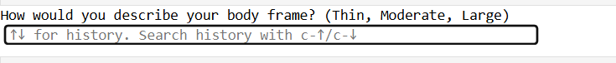
Fig 2: Prakruti Assessment

After asking a series of questions, the AyurSutra Bot will determine the dosha to which a person belongs and present the results with a graphical representation.

Additionally, the bot will provide personalized recommendations for dietary choices, lifestyle changes, and home remedies tailored to the individual’s specific dosha. This holistic approach ensures that users receive actionable insights to support their well-being and maintain balance in their lives.
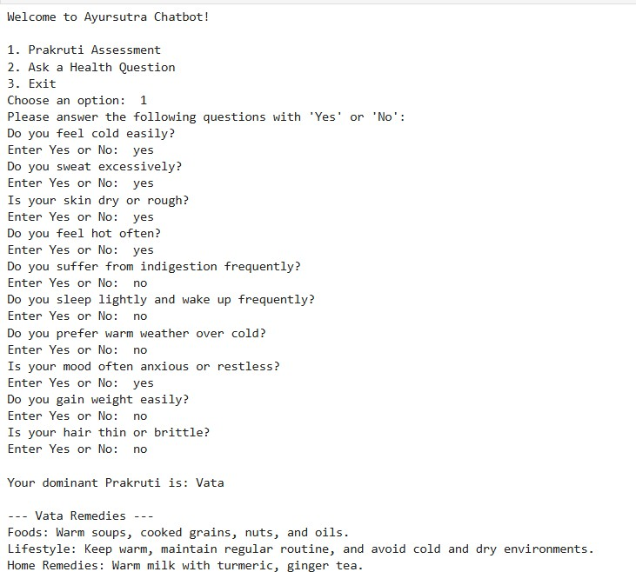

Fig 3: Dosha Detection
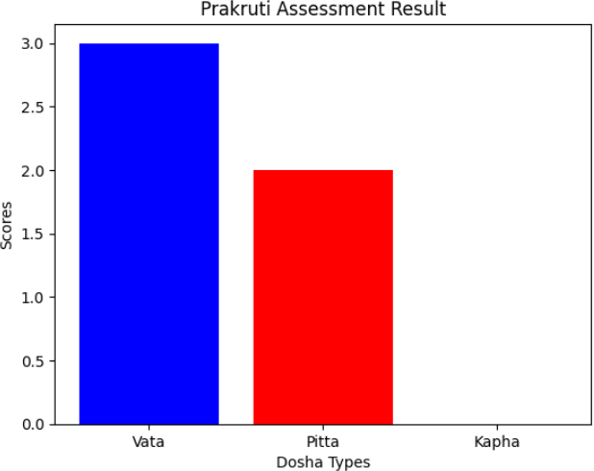

Fig 4: Bar graph of dominant dosha

Users can also inquire about specific health issues they are experiencing, and the AyurSutra Bot will provide tailored suggestions to address these concerns. By leveraging its knowledge of Ayurvedic principles, the bot will offer personalized recommendations, including dietary adjustments, lifestyle modifications, and home remedies that align with both the user’s Prakruti type and the particular health issues they face. This feature enhances the bot’s functionality, allowing it to serve as a comprehensive health assistant. Users can engage in an interactive dialogue, receiving insights not only about their dosha but also guidance on managing various ailments such as digestive issues, stress, fatigue, and common ailments like colds or headaches.

Identify applicable funding agency here. If none, delete this text box.
The AyurSutra Bot aims to empower users with knowledge and practical solutions, promoting overall well-being and encouraging a proactive approach to health management. By integrating personalized health advice with Ayurvedic wisdom, the bot strives to create a supportive environment for users seeking holistic remedies for their everyday health challenges.
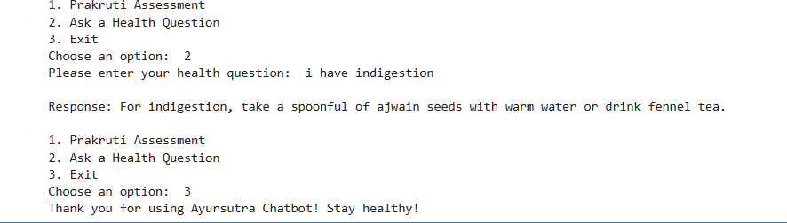
Fig 5: AyurSutra Bot

Conclusion
In conclusion, the AyurSutra Bot project represents a significant advancement in the integration of traditional Ayurvedic practices with modern technology, specifically through the application of machine learning and natural language processing. By providing a user-friendly platform for Prakruti assessment and personalized health recommendations, the bot enhances accessibility to holistic health guidance for a diverse audience. Its ability to analyze user responses, deliver graphical representations of dosha classifications, and offer tailored suggestions for dietary and lifestyle changes underscores its potential to empower individuals in managing their well-being effectively. Furthermore, by addressing specific health concerns and providing actionable insights, the AyurSutra Bot not only preserves the essence of Ayurveda but also adapts it to contemporary needs. Ultimately, this innovative approach aims to foster a greater understanding of personalized health, encouraging users to embrace Ayurvedic principles for improved quality of life and holistic well-being. In conclusion, the AyurSutra Bot project marks a transformative step toward merging the ancient wisdom of Ayurveda with the capabilities of modern technology, providing users with an intuitive and accessible means to assess their health and well-being. By utilizing machine learning algorithms and natural language processing, the bot not only streamlines the Prakruti assessment process but also enhances the accuracy and consistency of dosha classifications, eliminating the subjective nature often associated with traditional methods. The graphical representation of results allows users to visualize their Ayurvedic constitution, making the information more engaging and easier to understand. Additionally, the personalized recommendations for dietary adjustments, lifestyle modifications, and home remedies are tailored to each individual’s unique needs, promoting proactive health management. This holistic approach ensures that users receive comprehensive support in addressing specific

health concerns, fostering a deeper connection to their bodies and encouraging sustainable well-being practices.

Future Scope
The future scope of the AyurSutra Bot project is promising and expansive, with numerous opportunities for enhancement and application. As the field of artificial intelligence and machine learning continues to evolve, the bot can incorporate more advanced algorithms to improve the accuracy of Prakruti assessments and recommendations. Integrating additional data sources, such as user health histories, genetic information, and environmental factors, could further personalize the guidance provided, making it even more relevant to individual users. Moreover, expanding the chatbot’s capabilities to include voice recognition and response features would enhance user interaction, making the experience more intuitive and accessible, especially for those less familiar with technology. The introduction of multi-language support could also broaden the user base, allowing individuals from diverse linguistic backgrounds to benefit from Ayurvedic insights. In addition to health assessments, the AyurSutra Bot could evolve into a comprehensive health management platform that includes features like progress tracking, personalized wellness plans, and integration with wearable health devices. This would empower users to monitor their well-being actively and make informed lifestyle choices over time. Collaborations with healthcare professionals and Ayurvedic practitioners could further enhance the credibility and effectiveness of the recommendations, ensuring they are evidence-based and holistic. Ultimately, the AyurSutra Bot has the potential to play a pivotal role in promoting holistic health practices globally, raising awareness of Ayurvedic principles, and encouraging a more personalized approach to health and wellness in an increasingly health-conscious society. As interest in alternative medicine continues to grow, the project can lead to a greater integration of Ayurvedic practices into mainstream health management, benefiting countless
individuals seeking natural and personalized solutions for their well-being.

REFERENCES

- Sharma, P. (2006). "Principles of Ayurveda: A Comprehensive Guide to Ayurvedic Medicine." Ayurvedic Publications.
- Kumar, A., & Singh, P. (2018). "Role of Ayurveda in Personalized Medicine." Journal of Ayurveda and Integrative Medicine, 9(4), 243-248. DOI: 10.1016/j.jaim.2018.08.002
- Wang, X., et al. (2019). "Machine Learning for Healthcare: Review, Opportunities, and Threats." ACM Computing Surveys, 54(1), 1-35. DOI: 10.1145/3287568
- Jiang, F., et al. (2017). "Artificial Intelligence in Healthcare: Anticipating Challenges to Ethics, Privacy, and Bias." Health Affairs, 36(11), 1916-1922. DOI: 10.1377/hlthaff.2017.0840
- Gonzalez, A., & Pujol, F. (2020). "Natural Language Processing for Healthcare: A Review of Applications." Journal of Biomedical Informatics, 109, 103532. DOI: 10.1016/j.jbi.2020.103532
- Rani, S., & Rani, S. (2020). "Application of Machine Learning Techniques in Healthcare: A Review." International Journal of Healthcare Information Systems and Informatics, 15(2), 1-18.
DOI: 10.4018/IJHISI.2020040101
- Hinton, G. E., et al. (2006). "Reducing the Dimensionality of Data with Neural Networks." Science, 313(5786), 504-507. DOI: 10.1126/science.1127647
- Kumar, V., et al. (2019). "Role of Data Analytics in Personalized Healthcare: An Overview." Healthcare, 7(1), 1-9. DOI: 10.3390/healthcare7010001
- Bhandari, A., & Parashar, A. (2021). "Ayurveda and Machine Learning: A Review of Potential Applications." International Journal of Ayurvedic Medicine, 12(1), 45-51.
- Kumar, R., & Gupta, S. (2022). "Integration of Ayurveda with Machine Learning for Personalized Healthcare." Journal of Traditional Medicine & Clinical Naturopathy, 11(3), 1-6.

POSTER

bjnj

AyURSUTRA ChATBOT:
PERSOnALIzED InSIghTS fOR hOLISTIC WELL-

BEIng
PAGADALA DIVYA UNDER THE GUDIANCE OF MRS. T. SUNEETHA - ASSISTANT PROFESSOR

05. SySTEm DESIgn

01. ABSTRACT
The AyurSutra Bot: Personalized Insights for Holistic Well-being leverages machine learning to offer customized Ayurvedic health guidance based on individual Prakruti (constitution) types—Vata, Pitta, and Kapha. This intelligent chatbot provides users with personalized lifestyle recommendations, dietary suggestions, home remedies, and yogic practices tailored to their unique constitution. By integrating AI with Ayurvedic principles, the AyurSutra Bot enables users to manage common health issues holistically and promotes overall well-being. The project is designed to be user- friendly, accessible, and informative, helping both technical and non-technical users navigate their path to balanced health.
02. InTRODUCTIOn
The AyurSutra Bot is an innovative project that aims to combine the ancient wisdom of Ayurveda with the power of artificial intelligence to provide personalized health insights. The project focuses on assessing an individual’s Prakruti—the unique combination of the three doshas (Vata, Pitta, and Kapha)— which determines their physical and mental constitution. By analyzing the responses to a series of carefully crafted questions, the bot is able to identify the dominant dosha in the user's body and offer tailored advice on diet, lifestyle, home remedies, and yoga practices that align with their personal constitution.
The system design of the AyurSutra Chatbot project is structured to deliver a smooth and interactive experience for users seeking personalized Ayurvedic insights. The design integrates two primary modules: Prakruti Assessment and Health Remedies Chat, each developed to assess and respond based on user inputs. A streamlined interface is created using Streamlit, ensuring accessibility and simplicity for users. The backend consists of organized datasets for Prakruti-related questions and health remedies, enabling efficient retrieval and response. This modular design supports future enhancements, such as machine learning integrations, to improve predictive accuracy and user recommendations.

03. OBjECTIvE
  - Dominant dosha in the user's body and offer tailored advice on diet, lifestyle, h1)Prakruti- Based Health Assessment: To accurately assess users' Ayurvedic constitution (Prakruti type) using machine learning, enabling personalized health recommendations.
  - Customized Health Recommendations: To provide tailored Ayurvedic solutions, including diet, lifestyle, home remedies, and yogasanas, based on individual needs and health issues.
  - Holistic Health Education: To educate users on Ayurvedic principles and promote holistic well-being, offering insights on natural healing practices.
  - User-Friendly Chatbot Interface: To create an intuitive chatbot that allows users to easily inquire about health topics and receive immediate, personalized responses.
  - Seamless Integration of AI and Ayurveda: To bridge modern machine learning techniques with ancient Ayurvedic wisdom, creating a unique health-support tool accessible to all.

06. RESULTS
Ayurvedic insights for your wellness journey: Consult a healthcare professional for personalized care.

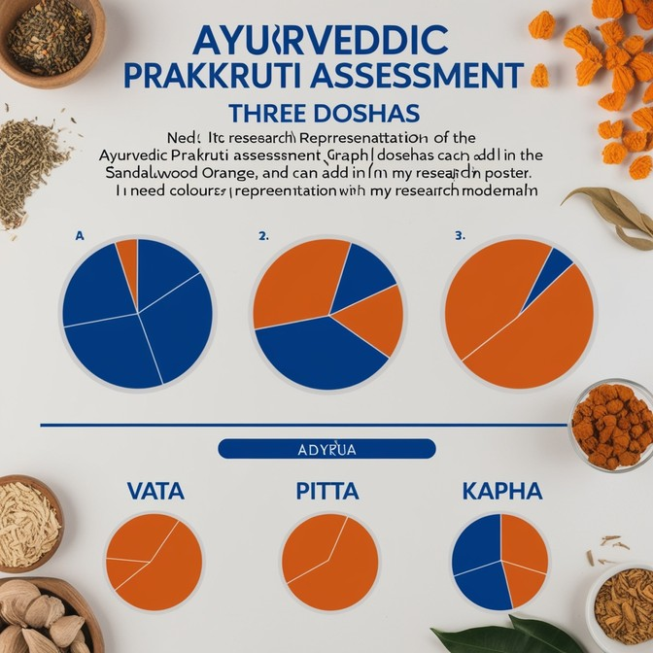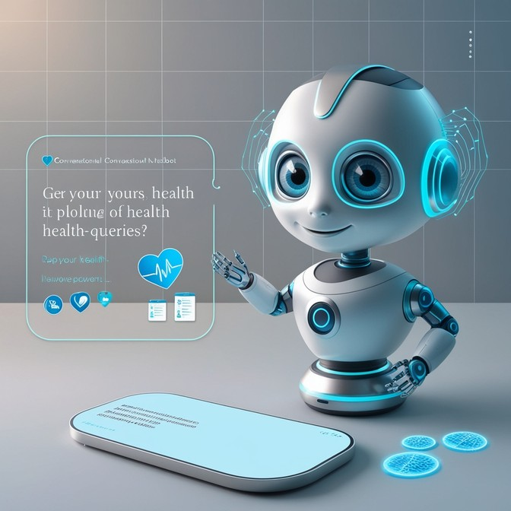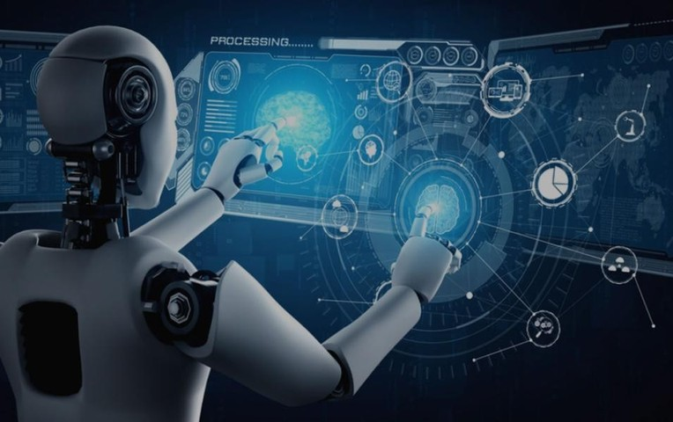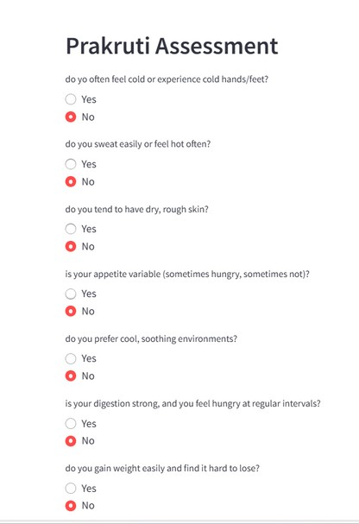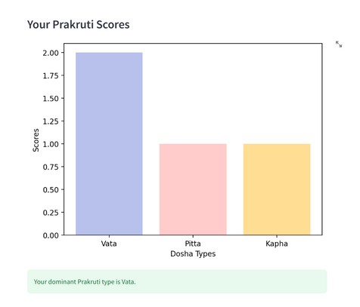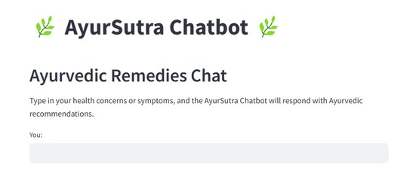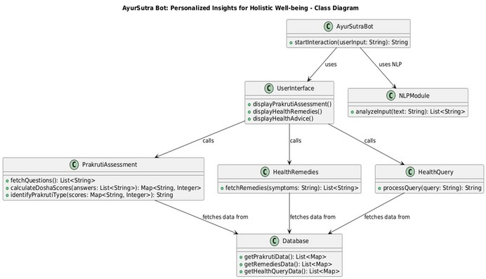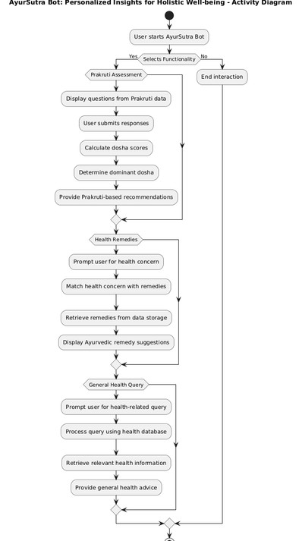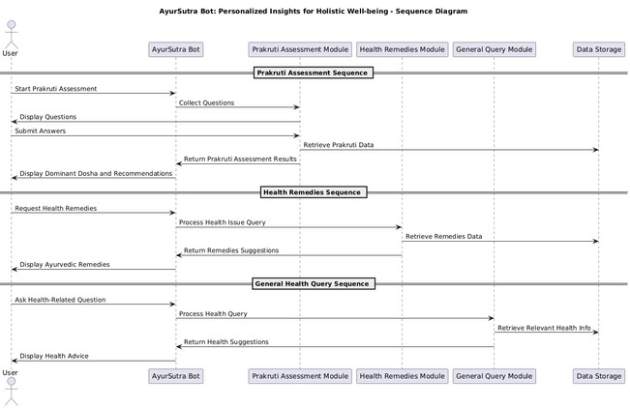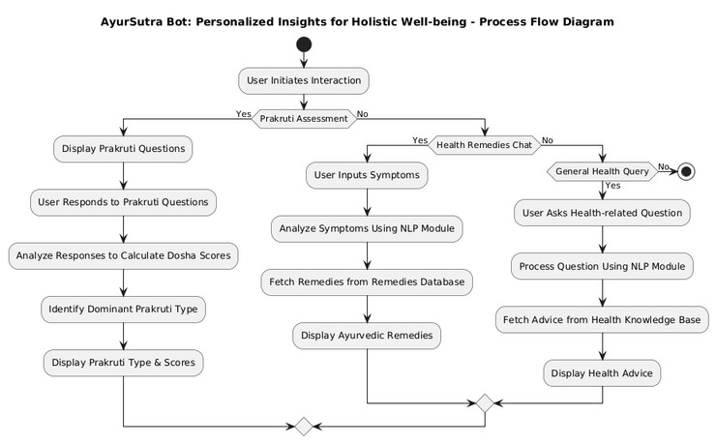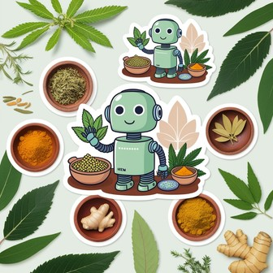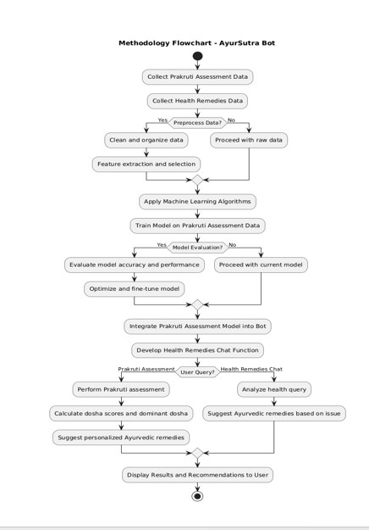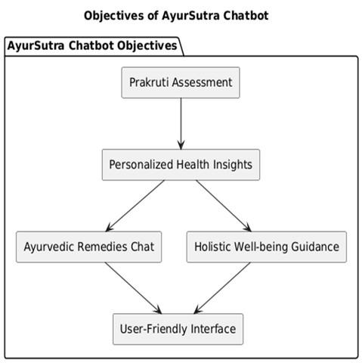04. METhODOLOgy
The AyurSutra Bot methodology involves collecting and preprocessing Ayurvedic data to classify users' Prakruti types using machine learning algorithms. The bot then delivers personalized recommendations by matching user inputs to relevant Ayurvedic remedies, ensuring a data- driven, user-friendly experience for holistic health guidance.

IMPORTANT!
AyurSutra: Inspiring better wellness decisions— partner with your healthcare provider for best results.

07. COnCLUSIOn

In conclusion, the AyurSutra Chatbot project serves as a pioneering step in merging traditional Ayurvedic wisdom with modern technology. By utilizing machine learning techniques, the chatbot provides users with personalized health insights and practical lifestyle recommendations, all grounded in Ayurvedic principles. This approach not only enhances accessibility to holistic health practices but also fosters an understanding of one’s unique body constitution (Prakruti) and its needs. The integration of AI ensures dynamic interactions and paves the way for future expansions, allowing for a broader impact on wellness and preventive healthcare.

